**HCM UNIVERSITY OF TECHNOLOGY AND EDUCATION**

**FACULTY OF INFORMATION TECHNOLOGY**

🙠🙟🕮🙝🙢



**Capstone Project**

**DEVELOPING A SOCCER FIELDS BOOKING MANAGEMENT WEBSITE USING REACT JS AND NODE JS**

**­Lecturer: Le Van Vinh, PhD.**

**Group Members:**

Danh Trường Sơn 20110394

Đặng Phước Trường Tài 20110396

Đặng Thanh Tuyên 20110412

**Ho Chi Minh City, June, 2024**

**HCM UNIVERSITY OF TECHNOLOGY AND EDUCATION**

**FACULTY OF INFORMATION TECHNOLOGY**

🙠🙟🕮🙝🙢



**Capstone Project**

**DEVELOPING A SOCCER FIELDS BOOKING MANAGEMENT WEBSITE USING REACT JS AND NODE JS**

**­Lecturer: Le Van Vinh, PhD.**

**Group Members:**

Danh Trường Sơn 20110394

Đặng Phước Trường Tài 20110396

Đặng Thanh Tuyên 20110412

**Ho Chi Minh City, June, 2024**

|  |  |
| --- | --- |
| C:\Users\HP\AppData\Local\Temp\ksohtml8\wps1.jpg | THE SOCIALIST REPUBLIC OF VIETNAM  Independence – Freedom– Happiness  -------- |

*Ho Chi Minh City, June 24, 2024*

**COMMENTARY OF ADVISOR**

Student name: Danh Trường Sơn Student ID: 20110394

Đặng Phước Trường Tài Student ID: 20110396

Đặng Thanh Tuyên Student ID: 20110412

Major: Information Technology.

Topic name: Developing a soccer fields booking management website using React JS and Node JS.

Name of Advisor: Lê Văn Vinh, PhD

**COMMENTARY**

1. On content of topic & workload done: ................................................................................................................................................ ................................................................................................................................................ ................................................................................................................................................ 2. Advantage: ................................................................................................................................................ ................................................................................................................................................ 3. Disadvantage: ................................................................................................................................................ ................................................................................................................................................ 4. Recommend for defense or not? ................................................................................ 5.Rating type: .................................................................................................................

6. Mark: ...................................................(By word:....................................................)

Ho Chi Minh, ………………………………. 2024

ADVISOR

(Name and signature)

|  |  |
| --- | --- |
| C:\Users\HP\AppData\Local\Temp\ksohtml8\wps1.jpg | THE SOCIALIST REPUBLIC OF VIETNAM  Independence – Freedom– Happiness  -------- |

*Ho Chi Minh City, June 24, 2024*

**COMMENTARY OF ADVISOR**

Student name: Danh Trường Sơn Student ID: 20110394

Đặng Phước Trường Tài Student ID: 20110396

Đặng Thanh Tuyên Student ID: 20110412

Major: Information Technology.

Topic name: Developing a soccer fields booking management website using React JS and Node JS.

Name of Advisor: Hoàng Văn Dũng, PhD

**COMMENTARY**

1. On content of topic & workload done: ................................................................................................................................................ ................................................................................................................................................ ................................................................................................................................................ 2. Advantage: ................................................................................................................................................ ................................................................................................................................................ 3. Disadvantage: ................................................................................................................................................ ................................................................................................................................................ 4. Recommend for defense or not? ................................................................................ 5.Rating type: .................................................................................................................

6. Mark: ...................................................(By word:....................................................)

Ho Chi Minh, ………………………………. 2024

ADVISOR

(Name and signature)

ACKNOWLEDGEMENT

For the completion of this thesis, I would like to express my sincere thanks to:

The Board of Directors of Ho Chi Minh City University of Technology and Education for creating favorable conditions in terms of facilities with a modern library system, a variety of books and documents that are convenient for searching and researching information.

I would like to thank the subject lecturer – Mr. Le Van Vinh for his dedicated and detailed teaching so that I have enough knowledge and apply them to this report.

Due to the lack of experience in making talent as well as the limitations of knowledge, in the report will certainly inevitably have shortcomings. We look forward to receiving comments, suggestions and criticism from the teacher to improve the report. Finally, I would like to wish you good health, success and happiness.

**TABLE OF CONTENT**

CHAPTER 1: INTRODUCTION 1

1.1. DESCRIPTION OF THE TOPIC 1

1.2. RESEARCH OBJECTS AND SCOPE 1

1.3. RELATED WORKS 1

1.3.1. Sport World 1

1.3.2. Sport Finder 3

1.3.3. Pitch Booking 4

CHAPTER 2: FUNDAMENTALS 6

2.1. FRONT-END DEVELOPMENT TECHNOLOGIES 6

2.1.1. ReactJS Framework 6

2.1.2. TailWind CSS 7

2.2. BACK-END DEVELOPMENT TECHNOLOGIES 7

2.2.1. NodeJS 7

2.2.2. ExpressJS 8

2.2.3. MongoDB 8

CHAPTER 3: REQUIREMENTS 9

3.1. USER REQUIREMENTS 9

3.1.1. Functional requirements 9

3.1.2. Non-functional requirements 11

3.2. REQUIREMENTS MODELING 12

3.2.1. Use case diagram 12

3.2.2. Use case specifications 14

CHAPTER 4: SYSTEM DESIGN 48

4.1. CLASS DIAGRAM 48

4.2. SEQUENCE DIAGRAM 49

4.2.1. Sign In 49

4.2.2. Sign Out 49

4.2.3. Sign Up 50

4.2.4. Recover Password 51

4.2.5. Filter Pitches 52

4.2.6. View Pitch Detail 52

4.2.7. View Booking History 53

4.2.8. Rating 53

4.2.9. Manage Personal Information 54

4.2.10. Manage Booking Orders 55

4.2.11. Manage Pitches 56

4.2.12. Manage Users 60

4.2.13. Manage Category 61

4.2.14. Booking 63

4.2.15. Brand 64

4.3. USER INTERFACE DESIGN 67

4.3.1. Home Page 67

4.3.2. Pitches Page 70

4.3.3. Pitch Detail Page 71

4.3.4. FAQs 72

4.3.4. Login/Sign Up Page 73

4.3.5. Personal Work space 74

4.3.6. Admin Workspace 76

4.3.7. Pitch Owner Workspace 94

4.3.8 My Order 100

4.3.9 Check Out 100

4.3.10 News Page 101

CHAPTER 5: IMPLEMENTATION AND TESTING 102

5.1. TTOOLS IN PROJECT 102

5.2. TEST PLAN 102

5.2.1. Test Plan 102

5.2.2. Test Result 103

CHAPTER 6: CONCLUSIONS 110

6.1. RESULT 110

6.2. LIMITATIONS 110

6.3. FUTURE WORK 110

REFERENCES 111

**LIST OF FIGURES**

Figure 1: Sport World Homepage 2

Figure 2: Dat San Truc Tiep Homepage 3

Figure 3: Pitch Booking home page 4

Figure 4: Node Js Application 7

Figure 5: Use case diagram of guest and user 12

Figure 6: Use case diagram of pitch owner and admin 13

Figure 7: Class diagram 48

Figure 8: Sign in sequence diagram 49

Figure 9: Sign Out sequence diagram 49

Figure 10: Sign Up sequence diagram 50

Figure 11: Recover password sequence diagram 51

Figure 12: Filter pitches sequence diagram 52

Figure 13: View pitch detail sequence diagram 52

Figure 14: View booking history sequence diagram 53

Figure 15: Rating sequence diagram 53

Figure 16: Manage personal information sequence diagram 54

Figure 17: View booking order sequence diagram 55

Figure 18: Delete booking order sequence diagram 55

Figure 19: View pitches sequence diagram 56

Figure 20: Create pitch sequence diagram 57

Figure 21: Edit pitch sequence diagram 58

Figure 22: Delete pitch sequence diagram 59

Figure 23: Edit user sequence diagram 60

Figure 24: Delete user sequence diagram 60

Figure 25: Create category sequence diagram 61

Figure 26: Edit category sequence diagram 61

Figure 27: Delete category sequence diagram 62

Figure 28: Booking sequence diagram 63

Figure 29: Create brand sequence diagram 64

Figure 30: Edit brand sequence diagram 65

Figure 31: Delete brand sequence diagram 65

Figure 32: Search pitches sequence diagram 66

Figure 33: Home Page 67

Figure 34: Home Page List of Pitches 68

Figure 35: Home Page Hot Deal 68

Figure 36: Home Page List of New 69

Figure 37: Home Page Contact by Email 69

Figure 38: Pitches Page 70

Figure 39: Pitch Detail Page 71

Figure 40: FAQs Page 72

Figure 41: Sign In Page 73

Figure 42: Manage Information Page 74

Figure 43: Booking Histories Page 75

Figure 44: Wish List Page 75

Figure 45: Admin Dashboard Page 76

Figure 46: Admin Manage User Page 77

Figure 47: Admin Manage Order Page 77

Figure 48: Admin Create Pitch Page 1 78

Figure 49: Admin Create Pitch Page 2 79

Figure 50: Admin Manage Pitches Page 80

Figure 51: Admin create category page 81

Figure 52: Admin Manage Category Page 82

Figure 53: Admin Update Category Page 82

Figure 54: Admin Create Brand Page 1 83

Figure 55: Admin Create Brand Page 2 84

Figure 56: Admin Manage Brands Page 85

Figure 57: Admin Create News Page 86

Figure 58: Admin Manage News Page 87

Figure 59: Admin Create FAQ’s Page 88

Figure 60: Manage FAQ’s Page 89

Figure 61: Admin Create Coupon Page 90

Figure 62: Admin Manage Coupon Page 91

Figure 63: Admin Create Notification Page 92

Figure 64: Admin Manage Notification Page 93

Figure 65: Pitch Owner Create Pitch Page 94

Figure 66: Pitch Owner Manage Pitch Page 95

Figure 67: Pitch Owner Create Brand Page 96

Figure 68: Pitch Owner Manage Order Page 97

Figure 69: Pitch Owner Create Coupon Page 98

Figure 70: Pitch Owner Manage Coupon Page 99

Figure 71: User Order Page 100

Figure 72: User Check Out Page 100

Figure 73: List Of News 101

LIST OF TABLES

Table 1: Use case sign in 15

Table 2: Use case sign up 16

Table 3: Use case sign out 17

Table 4: Use case recover password 18

Table 5: Use case filter pitches 19

Table 6: Use case view pitch detail 20

Table 7: Use case view booking history 21

Table 8: Use case rating 23

Table 9: Use case view personal information 24

Table 10: Use case edit personal information 25

Table 11: Use case view booking order 26

Table 12: Use case delete booking order 27

Table 13: Use case update pitch 29

Table 14: Use case add new pitch 30

Table 15: Use case delete pitch 31

Table 16: Use case view pitch detail 32

Table 17: Use case update user 34

Table 18: Use case delete user 35

Table 19: Use case view user detail 36

Table 20: Use case update category 37

Table 21: Use case add category 39

Table 22: Use case delete category 40

Table 23: Use case create brand 41

Table 24: Use Case Delete brand 43

Table 25: Use Case update brand 44

Table 26: Use case booking 46

Table 27: Use case searching pitches 47

Table 28: Test result 109

# CHAPTER 1: INTRODUCTION

## DESCRIPTION OF THE TOPIC

The group's topic is to design a website application that can help users and football players book soccer fields online, as well as help field owners easily promote and reach with more people playing the sport of soccer.

## RESEARCH OBJECTS AND SCOPE

The group's topic is to design a website application that can help users and football players book soccer fields online, as well as help field owners easily promote and reach them. with more people playing the sport of soccer. Surveying users' need to book a football field.

Through a survey of students at Ho Chi Minh City University of Technical Education, up to 60% of students have a need to book a football field online. There are many mixed opinions about this option, but most people want a soccer field booking website to make controlling appointments as well as money easier and more convenient. Therefore, we want to build an application that helps satisfy users' needs. Helping users make appointments for football fields. In addition, pitch owners can also post information about their football field. Make it easier to connect with football players.

## RELATED WORKS

### Sport World

* **Link:** <https://thegioithethao.vn>
* **Homepage:**

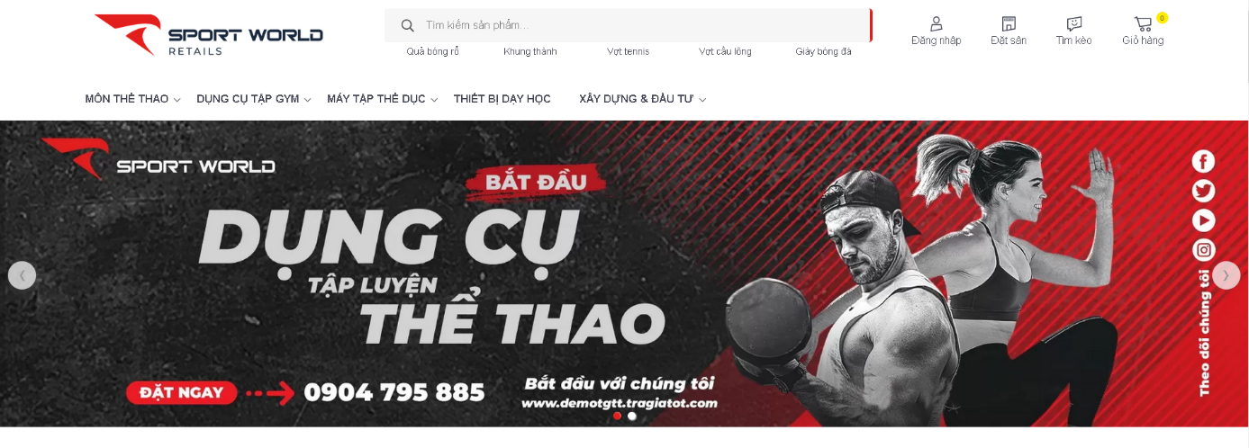

Figure 1: Sport World Homepage

* **Main function:**
* View, search, filter pitch
* Choose location
* Show the current information of the pitch (empty, booked, playing)
* Booking pitch
* Checkout
* Rating pitch
* **Strengths:**

+ Products are show with live photo

* You can look up order information (Utilities: Wifi, Parking lot, Shop)
* **Weaknesses:**
* Login and Sign Up Not Working
* Cannot be scheduled with another team
* No search results suggestions yet
* The header is not reasonable
* Website design is not eye-catching
* Products have not been classified in detail (Price, Type of Stadium, Reviews)

### Sport Finder

* **Link:** *https://datsantructuyen.vn/*
* **Homepage:**

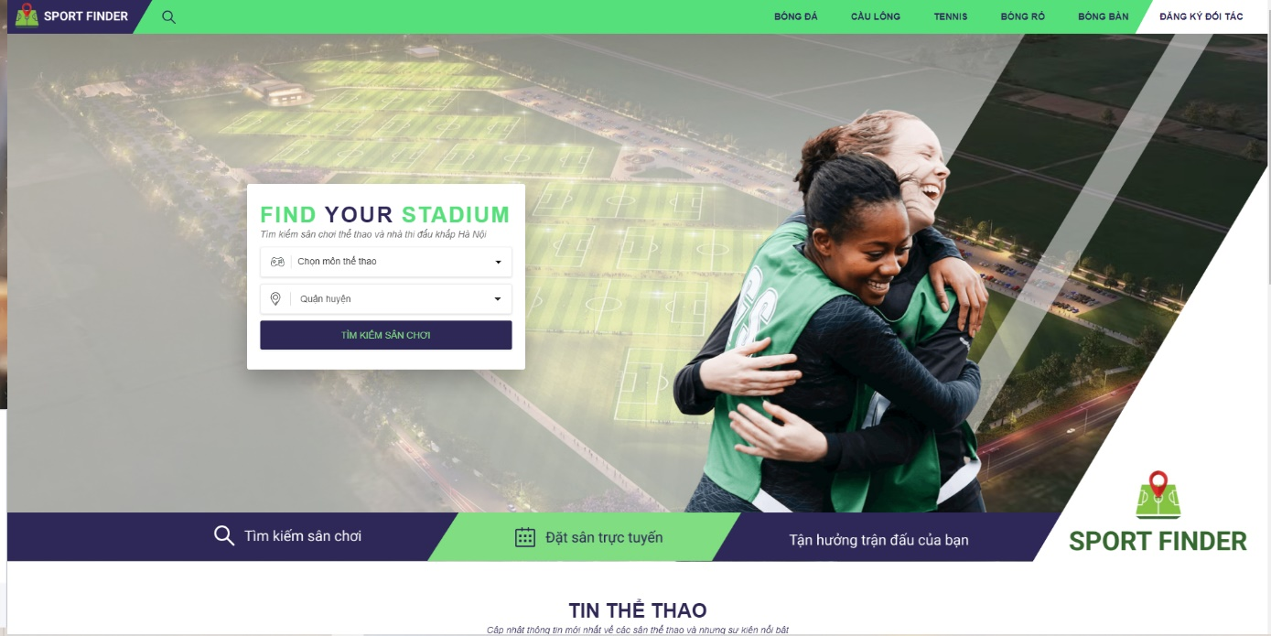

Figure 2: Dat San Truc Tiep Homepage

* **Main function:**
* View, search, filter pitch
* Choose location
* Booking pitch (send a request to manage by fill in the form)
* Rating pitch
* **Strengths:**

+ Products are show with live photo

* You can look up order information (Utilities: Wifi, Parking lot, Shop)
* Including many sport (badminton, basketball, tennis, ping-pong)
* UI/UX is friendly
* Can view the address of the pitches in google map.
* Can find the pitches according to many criteria (votes, location, type)
* **Weaknesses:**
* Don’t have Login and Sign Up
* Cannot be scheduled with another team

+ Can not create account for check out or deposit the money

### Pitch Booking

* **Link:** <https://pitchbooking.com/>
* **Homepage:**

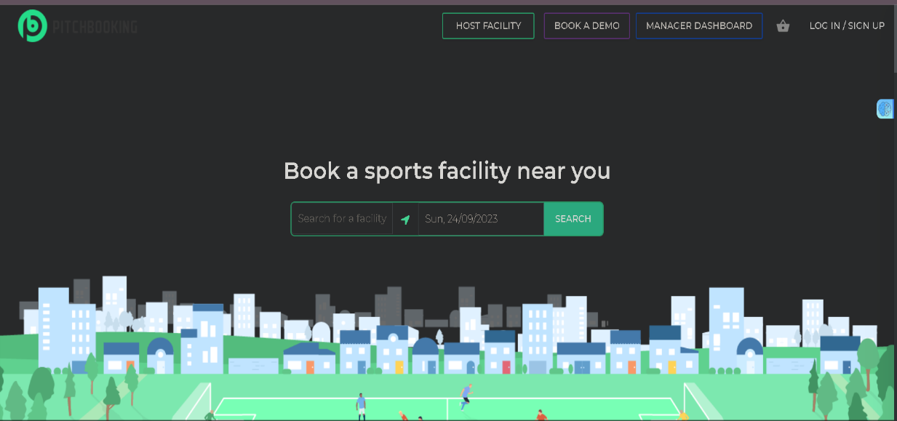

Figure 3: Pitch Booking home page

* **Main function:**
* View, search, filter pitch
* Choose location
* Booking pitch (send a request to manage by fill in the form)
* Rating pitch
* Have manager Dashboard
* Have Login and Sign Up
* Can book a demo
* **Strengths:**
* UI/UX is friendly
* Can find the pitches according to address
* Including many sport (badminton, cricket, Rugby, Hockey…)
* Can choose type of pitches and size
* **Weaknesses:**
* Cannot be scheduled with another team

+ Products are not show with photos

+ You cannot look up order information

+ Can not communicate with pitch owners

# 

# CHAPTER 2: FUNDAMENTALS

## 2.1. FRONT-END DEVELOPMENT TECHNOLOGIES

### 2.1.1. ReactJS Framework

**ReactJS** is a free open-source frontend JavaScript library created by Facebook's Jordan Walke to make user interfaces for both web and mobile systems based on components. React provide reusable code this will take less time and can show the parts of the UI that are changing without re-rendering the whole page. This makes the user experience much better, making the website feel faster. React also comes with two main features, making it stand out in the development. Number 2

**JSX (JavaScript Syntax Extension):** It is a syntactic extension that allows developers to write HTML in React more easily and place them in the DOM without any additional methods. JSX is utilized by React for creating templates instead of conventional JavaScript. Using JSX provides several benefits, such as enabling the rapid development of React applications, making it easier to optimize code compilation to JavaScript. JSX also allows React to display more comprehensive error information, resulting in greater efficiency. Number 2

**Virtual DOM (Document Object Model):** DOM stands for Document Object Model. It is the most crucial aspect of web development since it splits the code into modules and then executes it. When using JSX to manipulate and update the DOM, ReactJS creates a copy of the DOM called the Virtual DOM. React then compares the DOM and the Virtual DOM to determine which parts actually need to be changed whenever users interact with the page. React will selectively update the corresponding portion of the DOM. This significantly saves computational power and loading time. Number 2

### 2.1.2. TailWind CSS

Tailwind CSS is a utility-first CSS framework, similar to Bootstrap, Tailwind has built-in classes that we can use, encompassing various and crucial CSS properties. We can easily extend and create new classes based on its existing ones. Tailwind CSS facilitates the fastest website development with CSS properties already assigned as separate classes, making it straightforward to invoke and utilize. Number 1

## 2.2. BACK-END DEVELOPMENT TECHNOLOGIES

### 2.2.1. NodeJS

Node.js is an open-source, cross-platform JavaScript runtime environment that executes JavaScript code server-side. It is built on the V8 JavaScript runtime engine, which is the same engine that powers the Google Chrome browser. Node.js enables developers to use JavaScript for server-side scripting, allowing them to build scalable and high-performance network applications. Number 3

Node.js has gained popularity in the development community due to its speed, scalability, and the ability to use a single language (JavaScript) throughout the entire development stack. It has become a go-to choose for building modern web applications and server-side solutions. Number 3

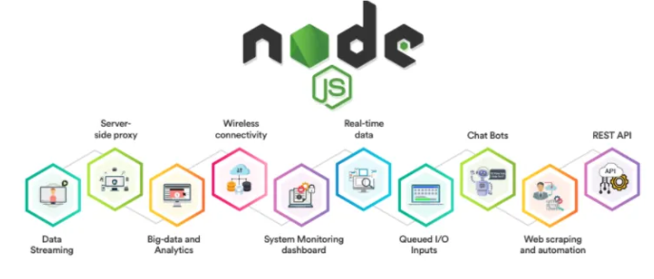

Figure 4: Node Js Application

### 2.2.2. ExpressJS

Express.js, commonly referred to as Express, is a minimal and flexible web application framework for Node.js. It provides a set of robust features to develop web and mobile applications quickly and with a minimal amount of code. Express.js is designed to be unopinionated, allowing developers the freedom to structure their applications according to their preferences while providing essential tools for building scalable and maintainable web servers. Number 5

Express.js is a web application framework that simplifies the process of building web applications and APIs using Node.js. It provides a set of tools and conventions for handling common web development tasks.

### 2.2.3. MongoDB

MongoDB is a widely used open-source NoSQL database management system that provides a flexible and scalable solution for storing, retrieving, and managing data. The name "MongoDB" is derived from the term "humongous" to emphasize its ability to handle large volumes of data. Number 4

MongoDB is classified as a NoSQL database, meaning it doesn't rely on the traditional relational database management system (RDBMS) model. Number 4 It is particularly well-suited for handling unstructured or semi-structured data.

MongoDB is widely used in various applications, ranging from small-scale projects to large, enterprise-level systems, due to its flexibility, scalability, and ease of use for developers working with modern, dynamic data models.

# 

# CHAPTER 3: REQUIREMENTS

## 3.1. USER REQUIREMENTS

### 3.1.1. Functional requirements

The system consists of the following main components:

1. Guest section:

* View the information about the pitches
* Register to the system
* Filter, find pitches
* View news
* View Faq’s
* Communicate with Chatbot

2. User section:

* Post and display personal information
* Change personal password
* Make payment
* View personal payment history
* Make, update, cancel booking
* View the information about the pitches, filter, find pitches
* View and delete notifications
* Make, update, delete ratings and comment
* Apply discount

3. Pitch Owner section:

* Pitch management
  + Adding pitches
  + Deleting pitches
  + Updating pitches
* Viewing detail’s pitches
  + Booking orders management
  + Viewing booking orders
  + Deleting booking orders
* Manage discount
  + Adding discount
  + Updating discount
  + Deleting discount
* Manage notifications
  + Adding notifications
  + Updating notifications
  + Deleting notifications
* Manage statistics
  + View revenue statistics
  + View order statistics
* Brand management
  + Adding brand
  + Updating brand
  + Deleting brand

4. Admin section:

All the functions of the pitch owner and the following additional functions:

* User management
  + Adding user
  + Deleting user
  + Updating user
* Category management
  + Adding category
  + Deleting category
  + Updating category
* News management
  + Adding news
  + Deleting news
  + Updating news
* FAQ management
  + Adding Faq’s
  + Deleting Faq’s
  + Updating Faq’s
* Notifications management
  + Adding notifications
  + Deleting notifications
  + Updating notifications

5. Application section:

* Dark mode/ Light mode
* Online Payment
* Bilingual function

### 3.1.2. Non-functional requirements

* The system ensures ease of use for users
* Application runs smoothly

## 3.2. REQUIREMENTS MODELING

### 3.2.1. Use case diagram



Figure 5: Use case diagram of guest and user



Figure 6: Use case diagram of pitch owner and admin

### 3.2.2. Use case specifications

#### 3.2.2.1. Use case “Sign In”

|  |  |
| --- | --- |
| Use Case ID | UC_SI |
| Use Case Name | Log in |
| Description | This use case allows the actor to login to the website |
| Actor | User, Pitch Owner, Administrator |
| Pre-Condition(s) | The actor’s account has already been created |
| Post-Condition(s) | The actor successfully logged into the website |
| Basic Flow | 1. Actor clicks “Sign in, Create account” button on the top header  2. The system displays the Sign In page  3. Actor enter the created account and password [E1]  4. Actor click Sign In button  5. The system checks Sign In information [E2]  6. The system moves the actor to the Homepage |
| Alternative Flow |  |
| Exception Flow | [E1]. If the input account is empty or the password or both, show warning message  [E2]. If the account or password is incorrect, show warning message |

Table 1: Use case sign in

#### 3.2.2.2. Use case “Sign Up”

|  |  |
| --- | --- |
| Use Case ID | UC_SU |
| Use Case Name | Sign Up |
| Description | This use case allows the actor to register a personal account to log in to the website |
| Actor | Guest |
| Pre-Condition(s) |  |
| Post-Condition(s) | Successful account registration |
| Basic Flow | 1. The actor clicks the “Sign in, Create account” button in top header  2. The system displays the Sign In page  3. Click to Sign Up  4. The actor fills in the information  5. The actor clicks the Register button  6. The system verifies the registration information [E1]  7. The system redirects to the login page |
| Alternative Flow |  |
| Exception Flow | [E1] If the email already exists, the system displays an error message and requests the Actor to enter a different email |

Table 2: Use case sign up

#### 3.2.2.3. Use case “Sign Out”

|  |  |
| --- | --- |
| Use Case ID | UC_SO |
| Use Case Name | Sign Out |
| Description | This use case allows the actor to sign out of the actor's account from the website |
| Actor | User, Pitch Owner, Administrator |
| Pre-Condition(s) | The actor has logged into the system |
| Post-Condition(s) | The actor is logged out of the account on the website |
| Basic Flow | 1. The actor selects “Sign Out” in the top header  2. The system deletes the user’s session  3. The system redirects the actor to the Homepage |
| Alternative Flow |  |
| Exception Flow |  |

Table 3: Use case sign out

#### 3.2.2.4. Use case “Recover password”

|  |  |
| --- | --- |
| Use Case ID | UC_RP |
| Use Case Name | Forgot password |
| Description | This use case allows the actor to reset their password |
| Actor | User, Pitch Owner |
| Pre-Condition(s) | The actor has registered an account |
| Post-Condition(s) | The actor has set a new password |
| Basic Flow | 1. The actor clicks the “Sign in or Create Account” button in top header  2. The system displays the Sign In page  3. The actor clicks “Forgot password”  4. The system displays a Forgot Password page  5. The Actor enters the email address  6. The Actor clicks "Submit” button  7. The system checks the email address [E1]  8. The system sends a link to email to recover the password  9. The actor accesses the page to reset the password via the link received in Gmail  10. The actor enters the new password and confirms the new password and clicks "Submit"  11. The system verifies the validity of the new password [E2]  12. The system saves the new password  13. The system redirects the actor to the login page |
| Alternative Flow |  |
| Exception Flow | [E1] If the Actor enters an invalid email, the system will display an error message and request the Actor to enter a valid email  [E2] If the Actor enters a mismatched confirmation password, the system will notify and request the Actor to retype the confirmation password |

Table 4: Use case recover password

#### 3.2.2.5. Use case “Filter pitches”

|  |  |
| --- | --- |
| Use Case ID | UC_FP |
| Use Case Name | Filter pitches |
| Description | This use case allows the actor to filter pitches based on criteria such as location, price, rating, etc.… |
| Actor | Guest, User, Pitches Owner |
| Pre-Condition(s) |  |
| Post-Condition(s) | The system displays pitches that match the actor's filtering criteria |
| Basic Flow | 1. The actor clicks Pitches section on the navigation bar  2. The system displays list pitches and filtering criteria (e.g., price, location, date, alphabet)  3. The actor selects the filtering criteria that they want to apply  4. The system displays the filtered pitches list [E1] |
| Alternative Flow |  |
| Exception Flow | [E1] If there are no pitches, display “No pitch to show” |

Table 5: Use case filter pitches

#### 3.2.2.6. Use case “View pitch detail”

|  |  |
| --- | --- |
| Use Case ID | UC_VPD |
| Use Case Name | View pitches’ detail |
| Description | This use case allows the actor to view filter details when the Actor clicks on the pitch, they want to view |
| Actor | Guest, User, Pitch Owner |
| Pre-Condition(s) |  |
| Post-Condition(s) | The actor can view pitch details |
| Basic Flow | 1. The actor select one Pitch on the page  2. The system displays the pitch detail page. |
| Alternative Flow |  |
| Exception Flow |  |

Table 6: Use case view pitch detail

#### 3.2.2.7. Use case “View booking history”

|  |  |
| --- | --- |
| Use Case ID | UC_VBO |
| Use Case Name | View booking history |
| Description | This use case allows the actor to view the history that they booking the pitch |
| Actor | User |
| Pre-Condition(s) | The actor has logged into the system |
| Post-Condition(s) |  |
| Basic Flow | 1. The actor select the “Personal” page  2. The actor select view “Booking histories”  3. The system displays a list of purchased orders history [E1] |
| Alternative Flow |  |
| Exception Flow | [E1] If there are no pitches in actor purchase history. Display "Show orders 0 – 0 of 0" |

Table 7: Use case view booking history

#### 3.2.2.8. Use case “Rating”

|  |  |
| --- | --- |
| Use Case ID | UC_R |
| Use Case Name | Rating |
| Description | This use case allows the Actor to rating pitch |
| Actor | User |
| Pre-Condition(s) | The actor has logged into the system and have booking pitch they want to rate at least one time |
| Post-Condition(s) | The actor success adds a new rating for a pitch |
| Basic Flow | 1. Actor select a pitch in Pitches page [A1]  2. The actor click on “Rating now!” [E1]  3. Comment input and rating starts show on, actor fill the input and choose rating starts  4. System check the validation of the input and rating start [E2]  5. System show the comment and star the user hast just rated |
| Alternative Flow |  |
| Exception Flow | [E1] If the user does not login it will require the user to login for rating.  [E2] If the input is not invalid or the rating starts is not selected, show warning message, request user to retype comment and choose a rating start. |

Table 8: Use case rating

#### 3.2.2.9. Manage Personal Information

##### *3.2.2.9.1.* Use case “View Personal Information”

|  |  |
| --- | --- |
| Use Case ID | UC_VPI |
| Use Case Name | View Information |
| Description | This use case allows the actor to view their account information |
| Actor | User, Pitch Owner, Admin |
| Pre-Condition(s) | The actor has logged into the system |
| Post-Condition(s) | The actor can view their personal information |
| Basic Flow | 1. The actor click “Profile” on the header  2. The actor click to the “Personal” on the span [E1]  3. The system go to the personal page  4. The system show the information of the user |
| Alternative Flow |  |
| Exception Flow | [E1] If the user does not login it will require the user to login |

Table 9: Use case view personal information

##### *3.2.2.9.2.* Use case “Edit Personal Information”

|  |  |
| --- | --- |
| Use Case ID | UC_EPI |
| Use Case Name | Edit Information |
| Description | This use case allows the actor to edit their account personal information. |
| Actor | User, Pitchowner, Admin |
| Pre-Condition(s) | The actor has logged into the system and accessed the account management screen |
| Post-Condition(s) | The actor successful change and save their personal information |
| Basic Flow | 1. The actor click “Profile” on the header  2. The actor click to the “Personal” on the span [E1]  3. The system go to the personal page  4. The actor fills in the information want to change  5. The system verifies the registration information [E2]  6. The actor click “Update information” to save new changes. |
| Alternative Flow |  |
| Exception Flow | [E1] If the user does not login it will require the user to login.  [E2] If the input is not invalid or the rating starts is not selected, show warning message, request user to retype information |

Table 10: Use case edit personal information

#### 3.2.2.10. Manage Booking Orders

##### 3.2.2.10.1 Use case “View booking orders”

|  |  |
| --- | --- |
| Use Case ID | UC_VBO |
| Use Case Name | View booking orders |
| Description | Use case for allowing actor to view the information of booking orders |
| Actor | Administrator, pitches owner |
| Pre-Condition(s) | The actor has logged in to the system |
| Post-Condition(s) |  |
| Basic Flow | 1. The actor accesses the management page  2. The actor clicks on the "Select Management" bar and chooses "Booking orders Management”  3. The system displays a list of orders and their details [E1]  4. The actor selects the order and clicks the view icon  5. The system displays the detailed information of that order |
| Alternative Flow |  |
| Exception Flow | [E1] If there are no orders in the order list, the system displays the message "No order is found" |

Table 11: Use case view booking order

##### 3.2.2.10.2 Use case “Delete booking orders”

|  |  |
| --- | --- |
| Use Case ID | UC_DBO |
| Use Case Name | Delete booking orders |
| Description | Use case for allowing the actor to delete the booking orders |
| Actor | Administrator, pitches owner |
| Pre-Condition(s) | The actor has logged into the system by manager account |
| Post-Condition(s) | The order has been successfully deleted |
| Basic Flow | 1. Actor accesses the management page  2. Actor clicks on the "Select Management" bar and chooses "Order Management”  3. The system displays a list of orders and their details [E1]  4. The actor selects the order and clicks the delete icon  5. The system displays a warning about deleting the order  6. The actor confirms delete action  7. The system displays a notification of successful order deletion |
| Alternative Flow |  |
| Exception Flow | [E1] If there are no orders in the order list, the system displays the message "No order is found" |

Table 12: Use case delete booking order

#### 3.2.2.11. Manage Pitch

##### 3.2.2.11.1. Use case “Update pitch”

|  |  |
| --- | --- |
| Use Case ID | UC_UP |
| Use Case Name | Update pitch |
| Description | Use case for allowing the actor to update the pitch |
| Actor | Administrator, pitch owner |
| Pre-Condition(s) | The actor has logged in to the system |
| Post-Condition(s) | The pitch’s information has been successfully updated. |
| Basic Flow | 1. The actor click “Profile” on the header  2. The actor click to the “Admin workspace” on the span [E1]  3. The system go to the admin page  4. The actor clicks to “Manage pitches”  5. The actor click to “Manage pitches” in the span  6. The actor click to icon edit to changes information  7. The actor input the information  8. The system verifies the registration information [E2]  9. The actor click “Update new pitch” button to save changes |
| Alternative Flow |  |
| Exception Flow | [E1] If the user does not login it will require the user to login  [E2] If the input is not invalid or the rating starts is not selected, show warning message, request user to retype information |

Table 13: Use case update pitch

##### 3.2.2.11.2. Use case “Add new pitch”

|  |  |
| --- | --- |
| Use Case ID | UC_AP |
| Use Case Name | Add pitch |
| Description | Use case for allowing the actor to add new the pitch information on the website |
| Actor | Administrator, pitches owner |
| Pre-Condition(s) | The actor has logged in to the system |
| Post-Condition(s) | The pitch information has been successfully added |
| Basic Flow | 1. The actor click “Profile” on the header  2. The actor click to the “Admin workspace” on the span [E1]  3. The system go to the admin page  4. The actor clicks to “Manage pitches”  5. The actor click to “Create pitch” to changes information  6. The actor input the information  7. The system verifies the registration information. [E2]  8. The actor click “Create new pitch” button to create new pitch |
| Alternative Flow |  |
| Exception Flow | [E1] If the user does not login it will require the user to login.  [E2] If the input is not invalid or the rating starts is not selected, show warning message, request user to retype information |

Table 14: Use case add new pitch

##### 3.2.2.11.3. Use case “Delete the pitch”

|  |  |
| --- | --- |
| Use Case ID | UC_DP |
| Use Case Name | Delete pitches |
| Description | Use case for allowing the actor to delete the pitches on the website |
| Actor | Administrator, pitches owner |
| Pre-Condition(s) | The actor has logged in to the system |
| Post-Condition(s) | The pitch has been successfully deleted from the website |
| Basic Flow | 1. The actor click “Profile” on the header  2. The actor click to the “Admin workspace” on the span [E1]  3. The system go to the admin page  4. The actor clicks to “Manage pitches”  5. The actor click to “Manage pitches” in the span  6. The actor click to icon delete to delete pitches  7. The system show a warning to confirm delete  8. The system delete the pitch user has choose |
| Alternative Flow |  |
| Exception Flow | [E1] If the user does not login it will require the user to login |

Table 15: Use case delete pitch

##### 3.2.2.11.4. Use case “View pitch detail”

|  |  |
| --- | --- |
| Use Case ID | UC_VPD |
| Use Case Name | View pitches detail |
| Description | Use case for allowing the actor to view the pitch information on the website |
| Actor | Administrator, pitches owner |
| Pre-Condition(s) | The actor has logged in to the system |
| Post-Condition(s) | . |
| Basic Flow | 1. The actor click “Profile” on the header  2. The actor click to the “Admin workspace” on the span [E1]  3. The system go to the admin page  4. The actor clicks to “Manage pitches”  4. The system show the information of the pitches |
| Alternative Flow |  |
| Exception Flow | [E1] If the user does not login it will require the user to login |

Table 16: Use case view pitch detail

3.2.2.12. Manage Users

##### 3.2.2.12.1. Use case “Update Users”

|  |  |
| --- | --- |
| Use Case ID | UC_UU |
| Use Case Name | Update user |
| Description | This use case allows the actor to update the user’s information to the system |
| Actor | Administrator |
| Pre-Condition(s) | The actor has logged in to the system. |
| Post-Condition(s) |  |
| Basic Flow | 1. The actor click “Profile” on the header  2. The actor click to the “Admin workspace” on the span [E1]  3. The system go to the admin page  4. The actor clicks to “Manage users”  5. The actor click to icon edit to changes information  6. The actor input the information  7. The system verifies the registration information [E2]  9. The actor click “Update” button to save changes |
| Alternative Flow |  |
| Exception Flow | [E1] If the user does not login it will require the user to login  [E2] If the input is not invalid or the rating starts is not selected, show warning message, request user to retype information |

Table 17: Use case update user

3.2.2.12.2. Use case “Delete Users”

|  |  |
| --- | --- |
| Use Case ID | UC_DU |
| Use Case Name | Delete user |
| Description | This use case allows the Actor to delete users from the system |
| Actor | Administrator |
| Pre-Condition(s) | The Actor has logged in to the system. |
| Post-Condition(s) |  |
| Basic Flow | 1. The actor click “Profile” on the header  2. The actor click to the “Admin workspace” on the span [E1]  3. The system go to the admin page  4. The actor clicks to “Manage users”  5. The actor click to icon delete to delete users  6. The system show a warning to confirm delete  7. The system delete the user has choose |
| Alternative Flow |  |
| Exception Flow | [E1] If the user does not login it will require the user to login  [E2] If the input is not invalid or the rating starts is not selected, show warning message, request user to retype information |

Table 18: Use case delete user

##### 3.2.2.12.3. Use case “View user detail”

|  |  |
| --- | --- |
| Use Case ID | UC_VUD |
| Use Case Name | View user detail |
| Description | This use case allows the Actor to view the user’s information |
| Actor | Administrator |
| Pre-Condition(s) | The Actor has logged in to the system |
| Post-Condition(s) |  |
| Basic Flow | 1. The actor click “Profile” on the header  2. The actor click to the “Admin workspace” on the span [E1]  3. The system go to the admin page  4. The actor clicks to “Manage users”  4. The system show the information of the users |
| Alternative Flow |  |
| Exception Flow | [E1] If the user does not login it will require the user to login. |

Table 19: Use case view user detail

#### 3.2.2.13. Manage Category

##### 3.2.2.13.1. Use case “Update category”

|  |  |
| --- | --- |
| Use Case ID | UC_UP |
| Use Case Name | Update category |
| Description | Use case for allowing the actor to update the category |
| Actor | Administrator |
| Pre-Condition(s) | The actor has logged in to the system |
| Post-Condition(s) | The category information has been successfully updated |
| Basic Flow | 1. The actor accesses the admin page  2. The actor chooses category management  3. The system displays the list of available categories on the website [E1]  4. Actor selects a category and clicks the edit icon  5. The system displays detailed information about the category  6. Actor enters the updated information for the category  7. Actor clicks the "Update Category" button to confirm the changes  8. The system verifies the updated information [E2]  9. The system saves the changes |
| Alternative Flow |  |
| Exception Flow | [E1] If there are no available category on the website, the system displays the message “Show category 0 – 0 of 0”  [E2]. If Actor does not enter complete or valid information, the system displays an error message and requests Actor to correct the information |

Table 20: Use case update category

##### 3.2.2.13.2. Use case “Add category”

|  |  |
| --- | --- |
| Use Case ID | UC_AP |
| Use Case Name | Add category |
| Description | Use case for allowing the actor to add category (information about football) on the website |
| Actor | Administrator |
| Pre-Condition(s) | The actor has logged in to the system |
| Post-Condition(s) | The category information has been successfully added |
| Basic Flow | 1. The actor accesses the admin page  2. The actor chooses category create  3. The system displays the form for actor to fill up  4. The actor enters the category information  5. The actor clicks the "Create new category" button to confirm adding  8. The system verifies the added category information. [E1]  9. The system saves the changes |
| Alternative Flow |  |
| Exception Flow | [E1]. If Actor does not enter complete or valid information, the system displays an error message and requests Actor to correct the information. |

Table 21: Use case add category

##### 3.2.2.13.3. Use case “Delete category”

|  |  |
| --- | --- |
| Use Case ID | UC_DP |
| Use Case Name | Delete category |
| Description | Use case for allowing the actor to delete the category on the website |
| Actor | Administrator |
| Pre-Condition(s) | The actor has logged in to the system. |
| Post-Condition(s) | The category has been successfully deleted from the website. |
| Basic Flow | 1. The actor accesses the admin page  2. The actor chooses category management.  3. The system displays the list of available categories on the website. [E1]  4. Actor selects a category and clicks the delete category icon.  5. The system displays a popup message asking the actor to confirm deletion  6. The actor confirms the delete action  7. The system displays a notification of successful category deletion |
| Alternative Flow |  |
| Exception Flow | [E1] If there are no available category on the website, the system displays the message "No category is found" |

Table 22: Use case delete category

#### 3.2.2.14. Manage Brand

##### 3.2.2.14.1. Use case “Create Brand”

|  |  |
| --- | --- |
| Use Case ID | UC_CB |
| Use Case Name | Create Brand |
| Description | This use case allows the actor to create a brand |
| Actor | Administrator |
| Pre-Condition(s) | The actor has logged in to the system. |
| Post-Condition(s) |  |
| Basic Flow: | 1. The actor click “Profile” on the header  2. The actor click to the “Admin workspace” on the span [E1]  3. The system go to the admin page  4. The actor clicks to “Manage Brand”  5. The actor clicks to “Create Brand”  6. The actor input the information  7. The system verifies the registration information [E2]  9. The actor click “Create new Brand” button to create |
| Alternative Flow |  |
| Exception Flow: | [E1] If the user does not login it will require the user to login  [E2] If the input is not invalid or the rating starts is not selected, show warning message, request user to retype information |

Table 23: Use case create brand

##### 3.2.2.14.2. Use case “Delete Brand”

|  |  |
| --- | --- |
| Use Case ID | UC_DB |
| Use Case Name | Delete Brand |
| Description | This use case allows the Actor to delete brand from the system |
| Actor | Administrator |
| Pre-Condition(s) | The Actor has logged in to the system |
| Post-Condition(s) |  |
| Basic Flow: | 1. The actor click “Profile” on the header  2. The actor click to the “Admin workspace” on the span [E1]  3. The system go to the admin page  4. The actor clicks to “Manage Brand”  5. The actor click to icon delete to delete brand  6. The system show a warning to confirm delete  7. The system delete the user has choose |
| Alternative Flow |  |
| Exception Flow: | [E1] If the user does not login it will require the user to login  [E2] If the input is not invalid or the rating starts is not selected, show warning message, request user to retype information |

Table 24: Use Case Delete brand

##### 3.2.2.14.3. Use case “Update Brand”

|  |  |
| --- | --- |
| Use Case ID | UC_UB |
| Use Case Name | Update Brand |
| Description | This use case allows the Actor to update brand’s information |
| Actor | Administrator |
| Pre-Condition(s) | The Actor has logged in to the system |
| Post-Condition(s) |  |
| Basic Flow: | 1. The actor click “Profile” on the header  2. The actor click to the “Admin workspace” on the span [E1]  3. The system go to the admin page  4. The actor clicks to “Manage Brand”  5. The actor click to icon edit to update brand  6. The system show a form to enters updated information for the brand  7. Actor clicks the "Update Brand" button to confirm the changes  8. The system verifies the updated information [E2]  9. The system saves the changes |
| Alternative Flow |  |
| Exception Flow: | [E1] If the user does not login it will require the user to login  [E2] If Actor does not enter complete or valid information, the system displays an error message and requests Actor to correct the information |

Table 25: Use Case update brand

#### 3.2.2.15. Use case “Booking”

|  |  |
| --- | --- |
| Use Case ID | UC_B |
| Use Case Name | Booking |
| Description | This use case allows the actor to booking a pitch with a specific time |
| Actor | User |
| Pre-Condition(s) | The actor has logged into the system |
| Post-Condition(s) | The actor booking pitch success |
| Basic Flow | 1. The actor select a pitch in home page or in pitches page  2. The system displays the pitch detail page  3. The actor select shift and date want to book  4. The actor click “Booking” [E1]  5. The pitch will be adding to cart  6. The actor click icon “Cart” to view their cart  7. The actor click “Check out Detail” to view order detail page [A1]  8. The actor click “Check out” to open Paypal check out page [A2]  9. The actor click “Paypal” to login with Paypal account  10. The actor fill up their information to login [E2]  11. The actor click “Complete Purchase” to success booking [E3]  12. System save the information of actor have booked and pitch that actor book |
| Alternative Flow | [A1] The actor can delete the pitch in the cart by click delete icon  [A2]: The actor can click “booking other” to continue booking other pitch |
| Exception Flow | [E1]: If the pitch was booked at the same time and shift actor select, system will show error notification  [E2]: If the information was incorrect the system will show message require actor to input again  [E3]: If the money in actor Paypal account was not enough system will show error message |

Table 26: Use case booking

#### 3.2.2.16. Use Case “Searching Pitches”

|  |  |
| --- | --- |
| Use Case ID | UC_SP |
| Use Case Name | Search pitches |
| Description | This use case allows the actor to find pitches based on their name |
| Actor | Guest, User, Pitches Owner |
| Pre-Condition(s) |  |
| Post-Condition(s) | The system displays a list of pitches match to the name has entered |
| Basic Flow | 1. The actor clicks Pitches section on the navigation bar.  2. The system displays list pitches and a search bar  3. The actor enter the name of the pitches to search bar.  4. The system displays the pitches which name contain character in search bar [E1] |
| Alternative Flow |  |
| Exception Flow | [E1] If there are no pitches that match the search criteria, the system displays the message "No results found". |

Table 27: Use case searching pitches

# CHAPTER 4: SYSTEM DESIGN

## 4.1. CLASS DIAGRAM



Figure 7: Class diagram

## 4.2. SEQUENCE DIAGRAM

### 4.2.1. Sign In

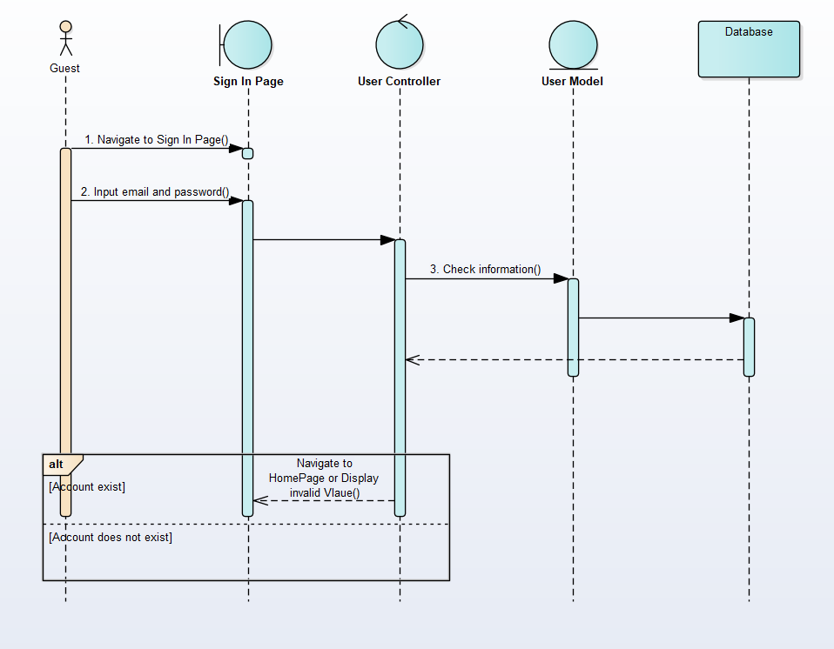

Figure 8: Sign in sequence diagram

### 4.2.2. Sign Out

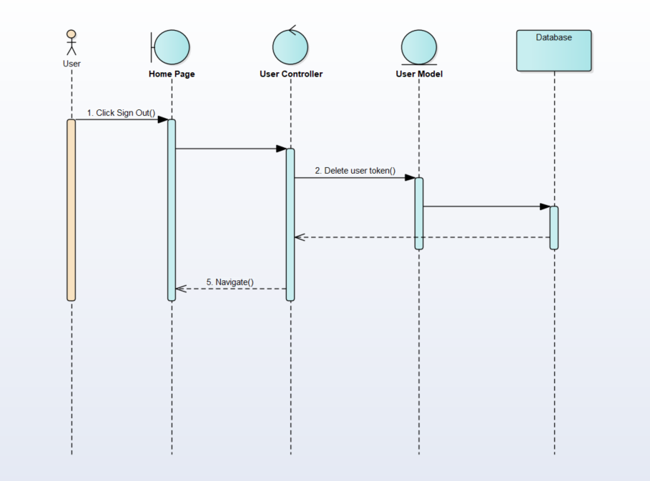

Figure 9: Sign Out sequence diagram

### 4.2.3. Sign Up

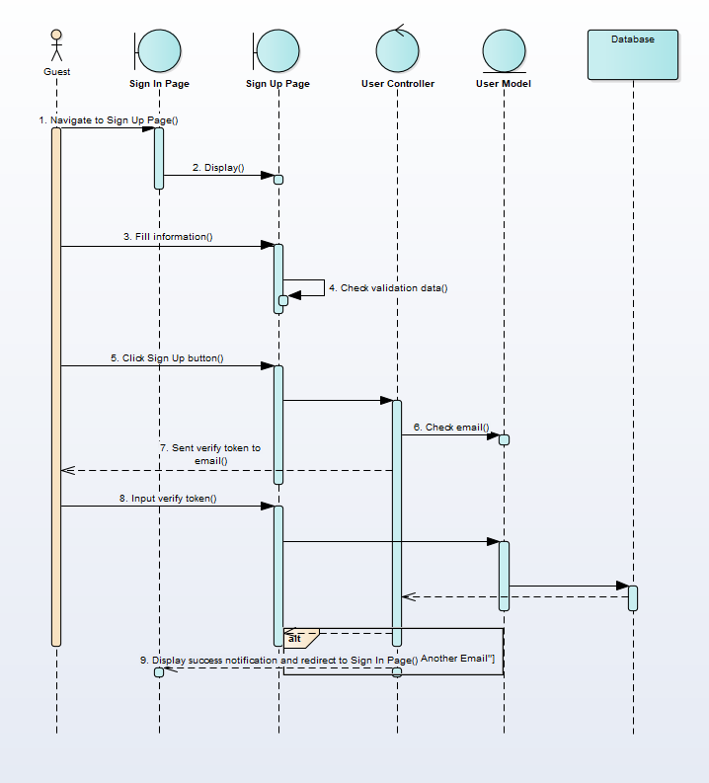

Figure 10: Sign Up sequence diagram

### 4.2.4. Recover Password

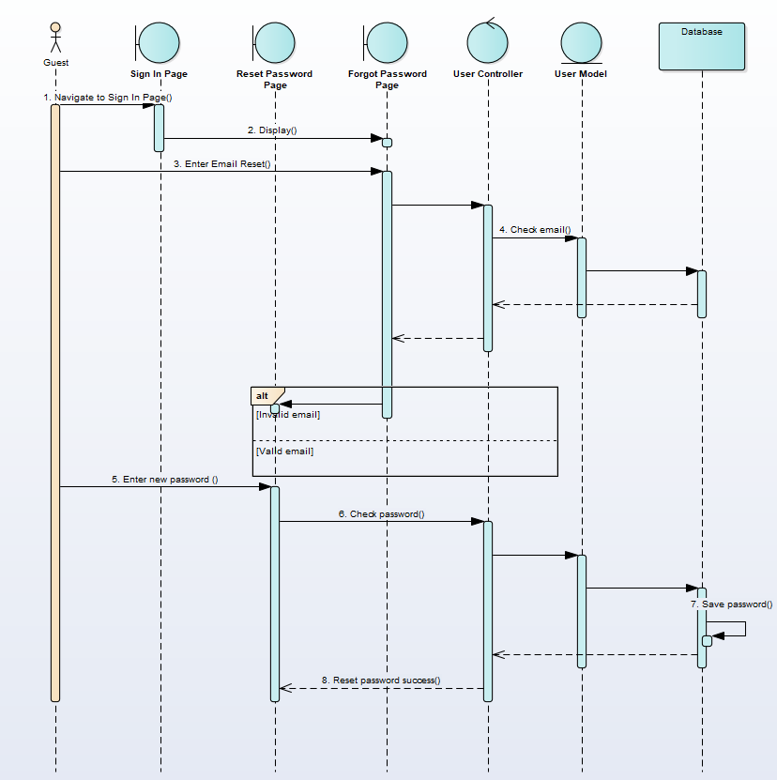

Figure 11: Recover password sequence diagram

### 4.2.5. Filter Pitches

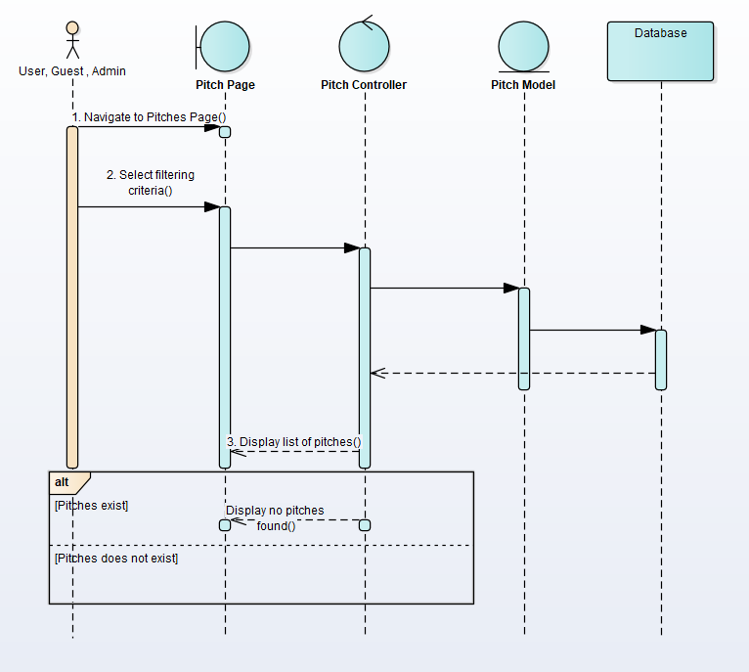

Figure 12: Filter pitches sequence diagram

### 4.2.6. View Pitch Detail

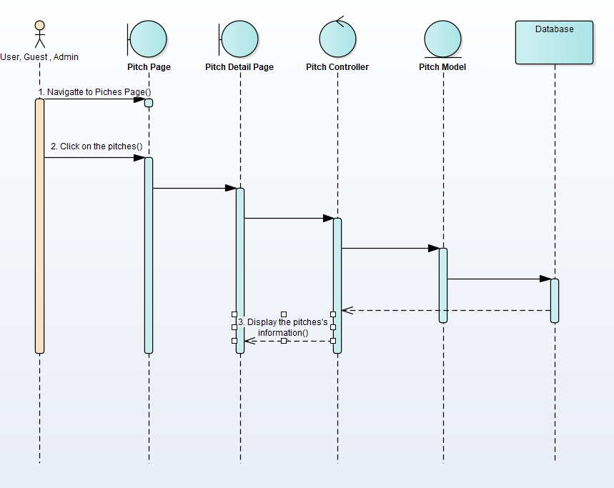

Figure 13: View pitch detail sequence diagram

### 4.2.7. View Booking History

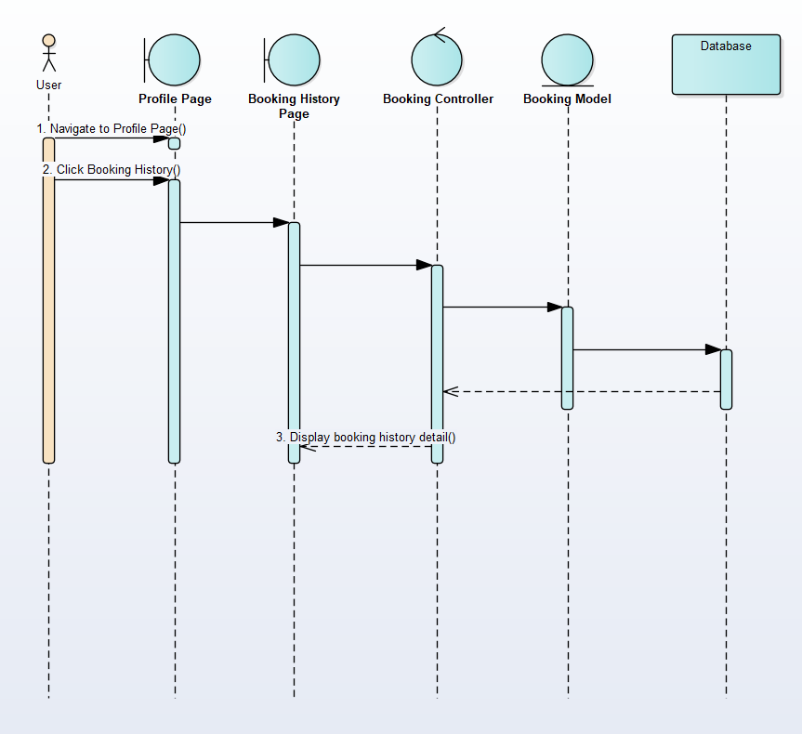

Figure 14: View booking history sequence diagram

### 4.2.8. Rating

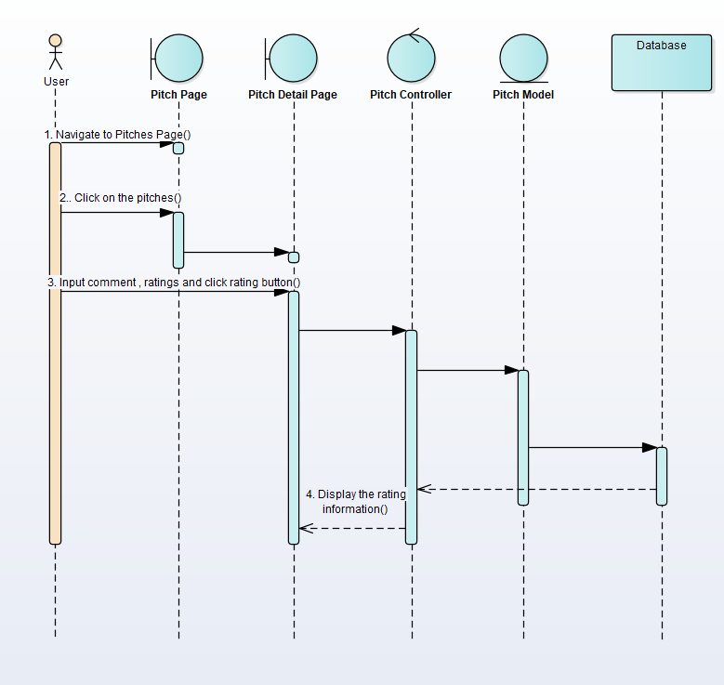

Figure 15: Rating sequence diagram

### 4.2.9. Manage Personal Information

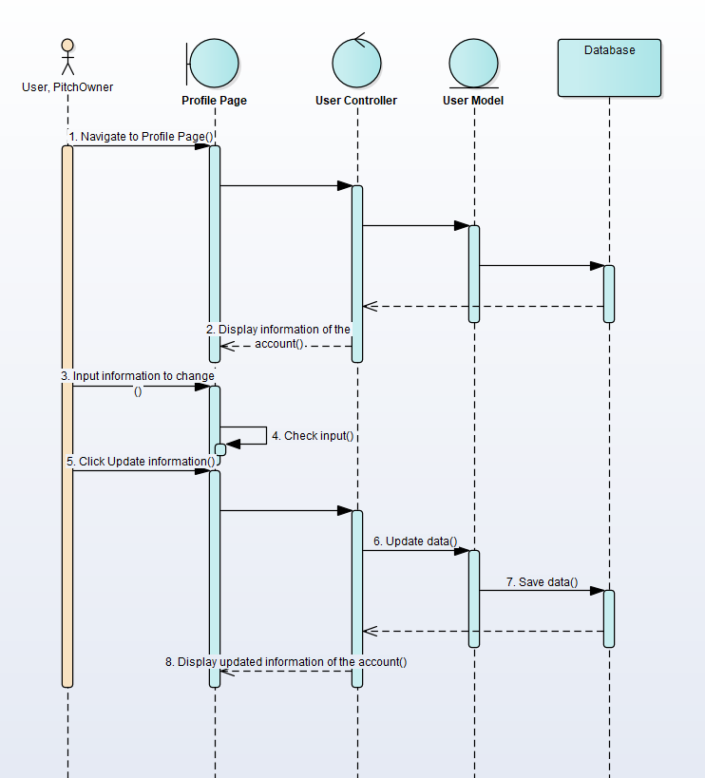

Figure 16: Manage personal information sequence diagram

### 4.2.10. Manage Booking Orders

#### 4.2.10.1. View Booking Orders

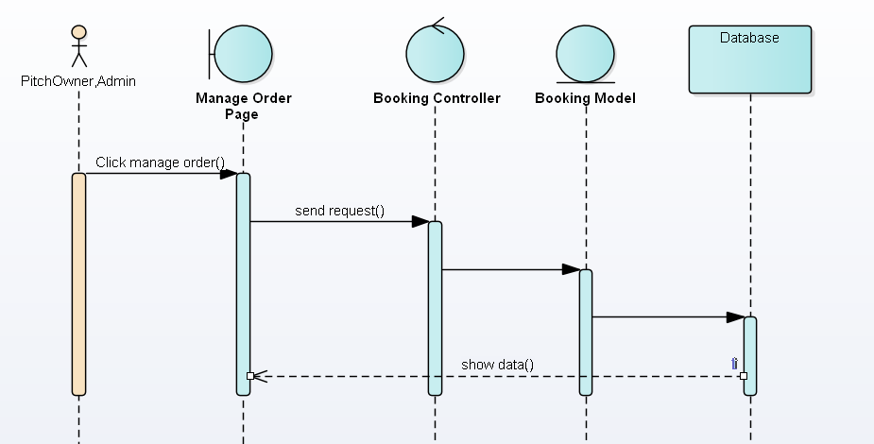

Figure 17: View booking order sequence diagram

#### 4.2.11.2. Delete Booking Order

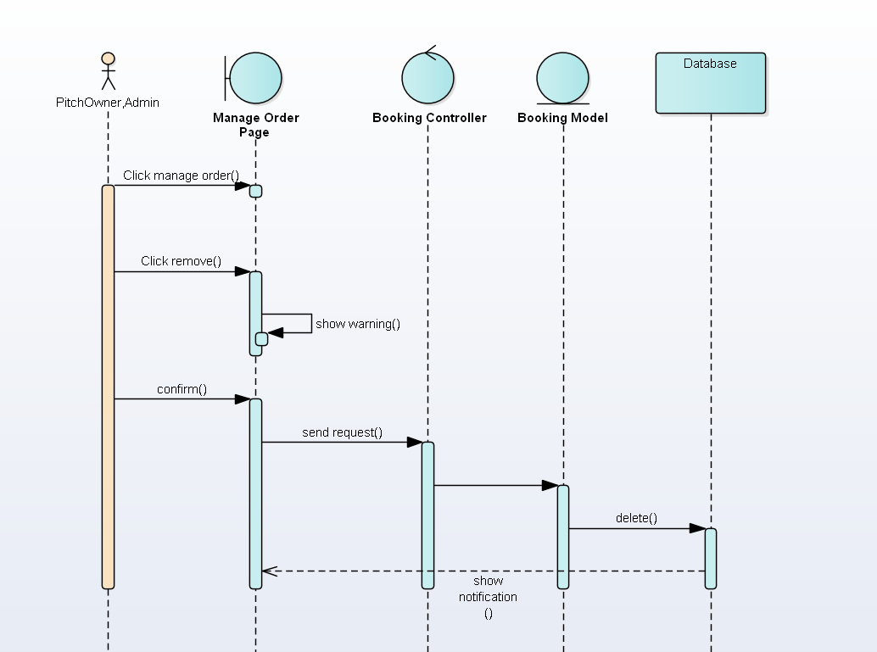

Figure 18: Delete booking order sequence diagram

### 4.2.11. Manage Pitches

#### 4.2.11.1. View Pitches

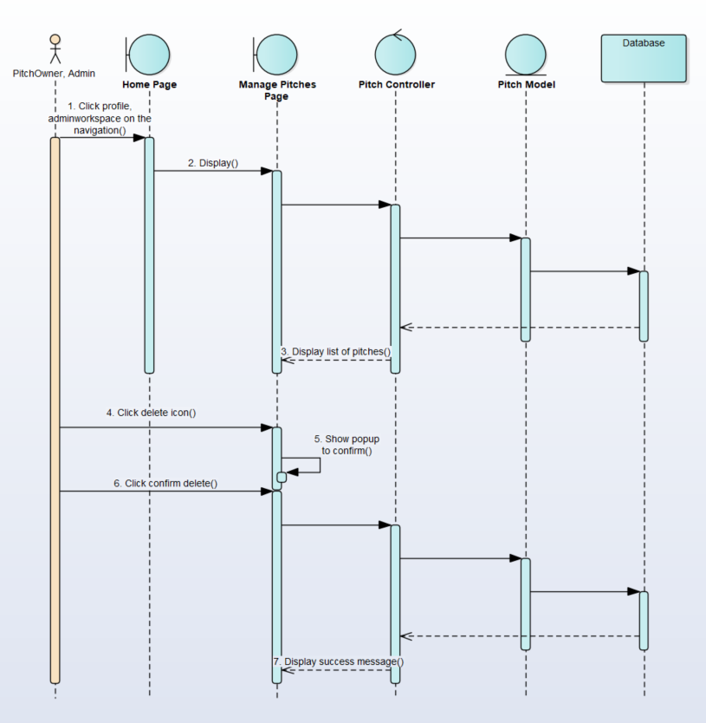

Figure 19: View pitches sequence diagram

#### 4.2.11.2. Create Pitch

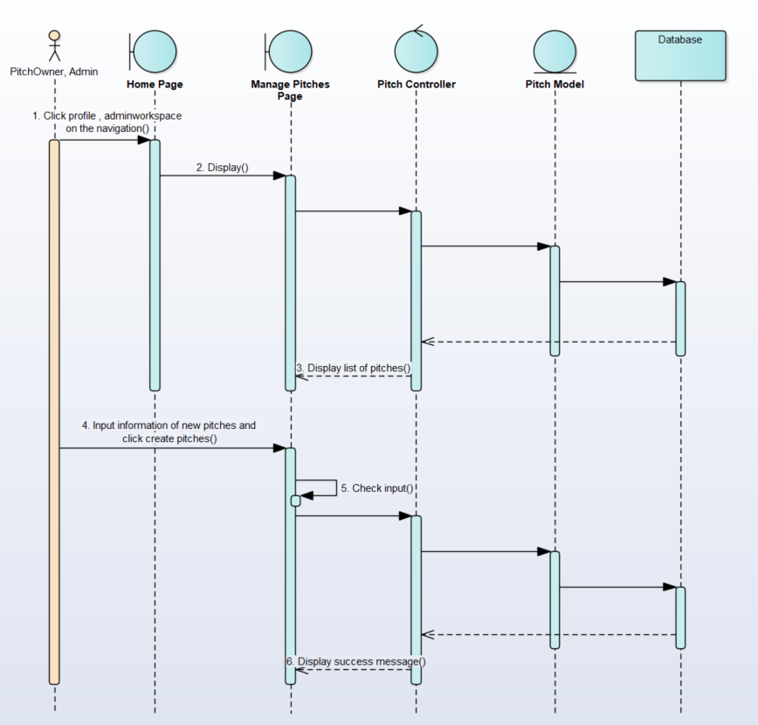

Figure 20: Create pitch sequence diagram

#### 4.2.12.3. Edit Pitch

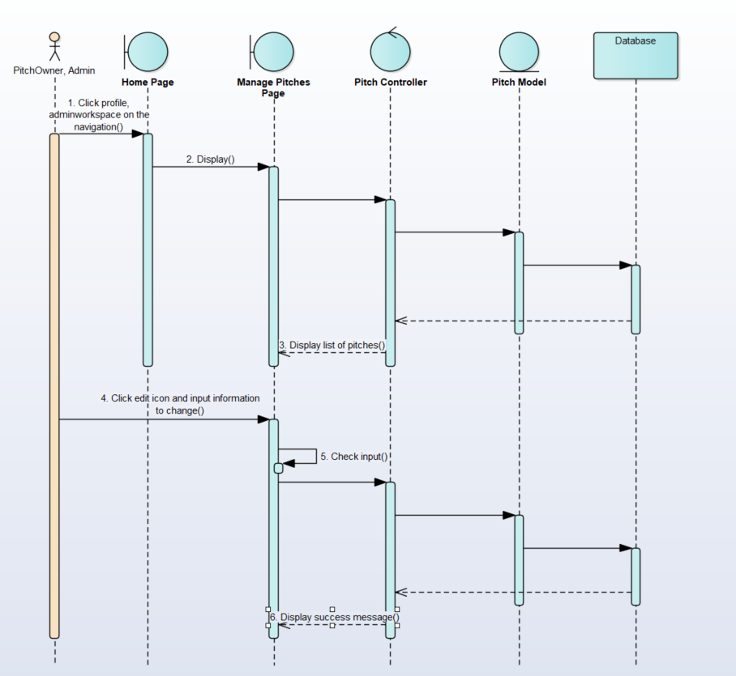

Figure 21: Edit pitch sequence diagram

#### 4.2.12.4. Delete Pitch



Figure 22: Delete pitch sequence diagram

### 4.2.12. Manage Users

#### 4.2.12.1. Edit User

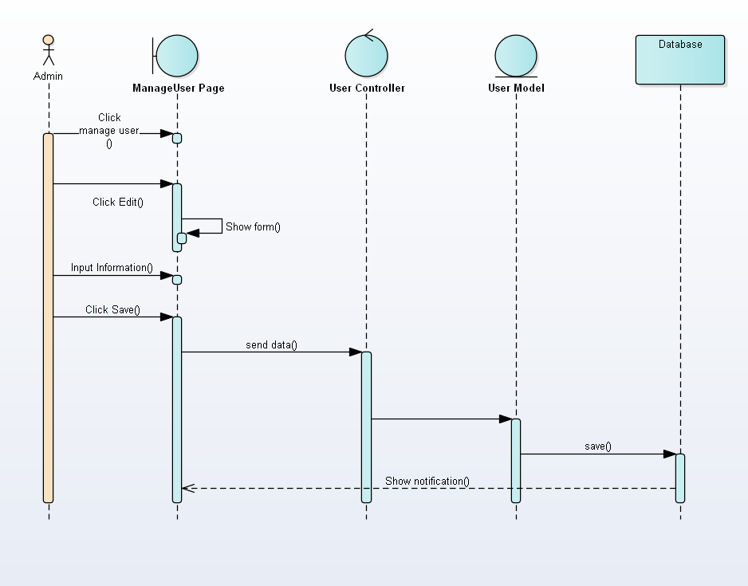

Figure 23: Edit user sequence diagram

#### 4.2.12.2. Delete User

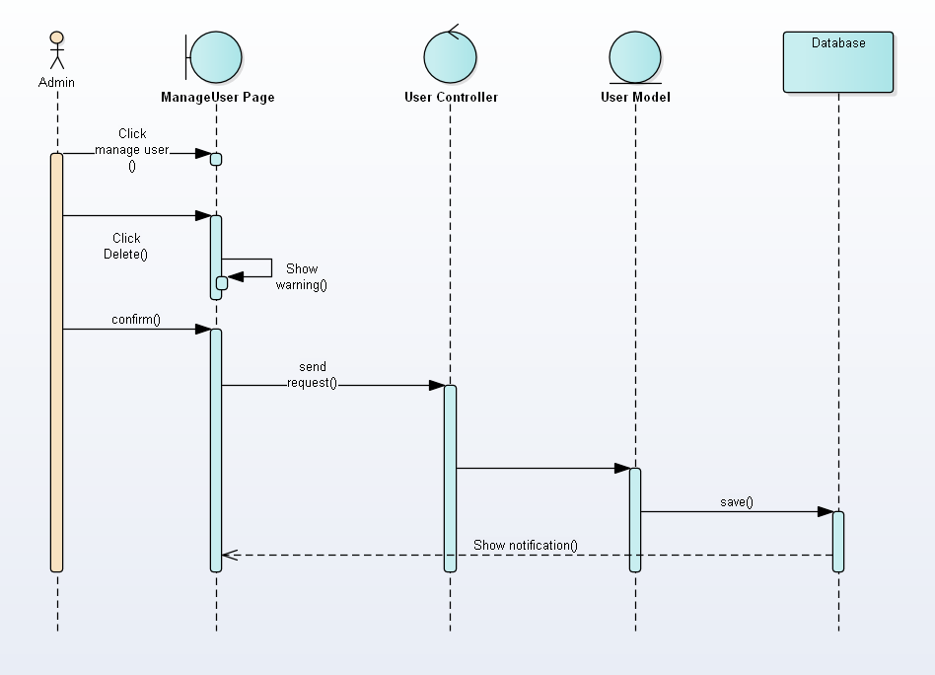

Figure 24: Delete user sequence diagram

### 4.2.13. Manage Category

#### 4.2.13.1. Create Category

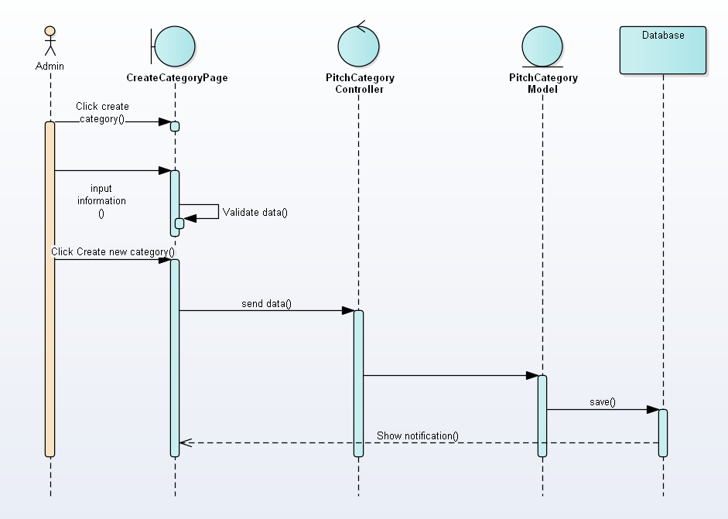

Figure 25: Create category sequence diagram

#### 4.2.13.1. Edit Category

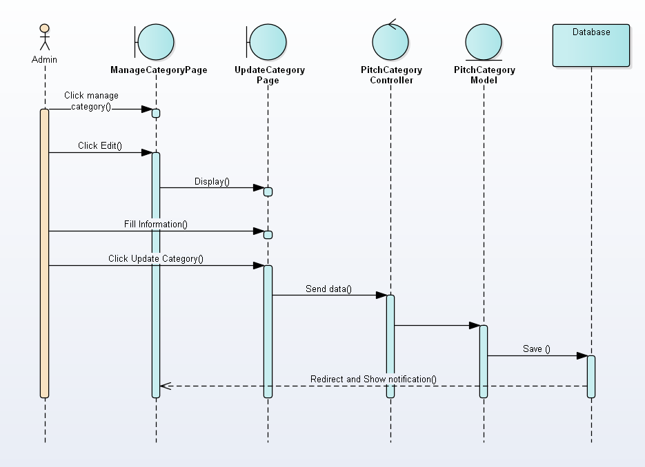

Figure 26: Edit category sequence diagram

#### 4.2.13.2. Delete Category

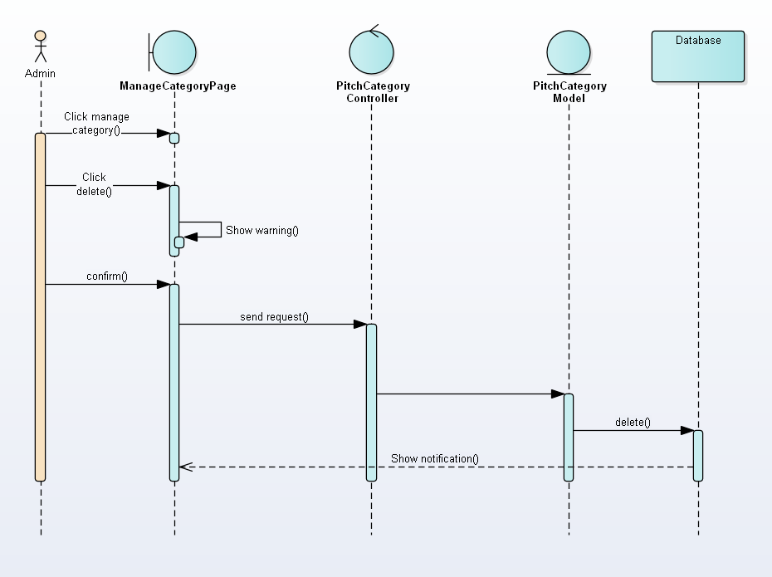

Figure 27: Delete category sequence diagram

### 4.2.14. Booking

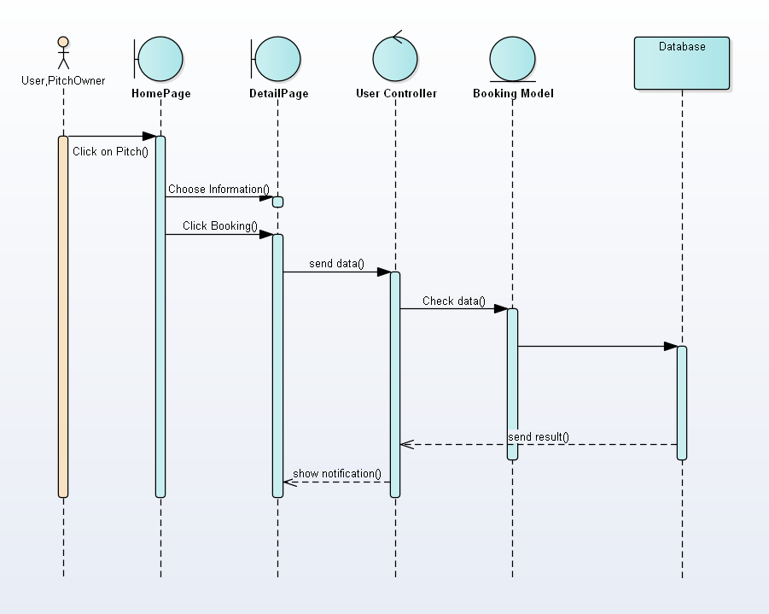

Figure 28: Booking sequence diagram

### 4.2.15. Brand

#### 4.2.15.1. Create Brand

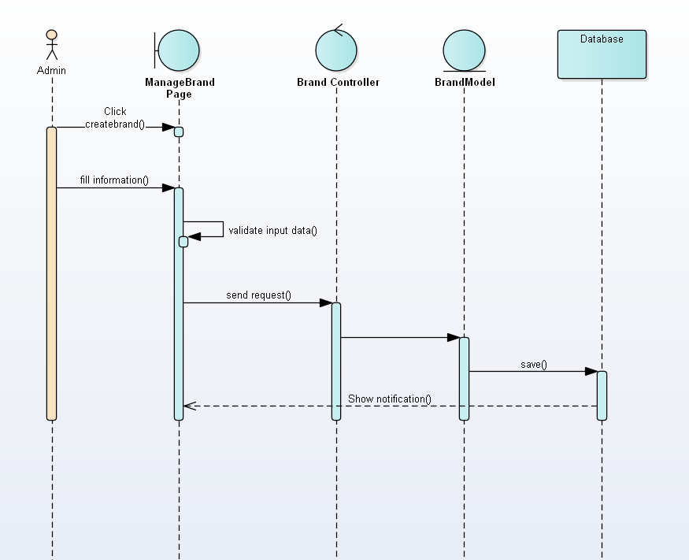

Figure 29: Create brand sequence diagram

#### 4.2.15.2. Edit Brand

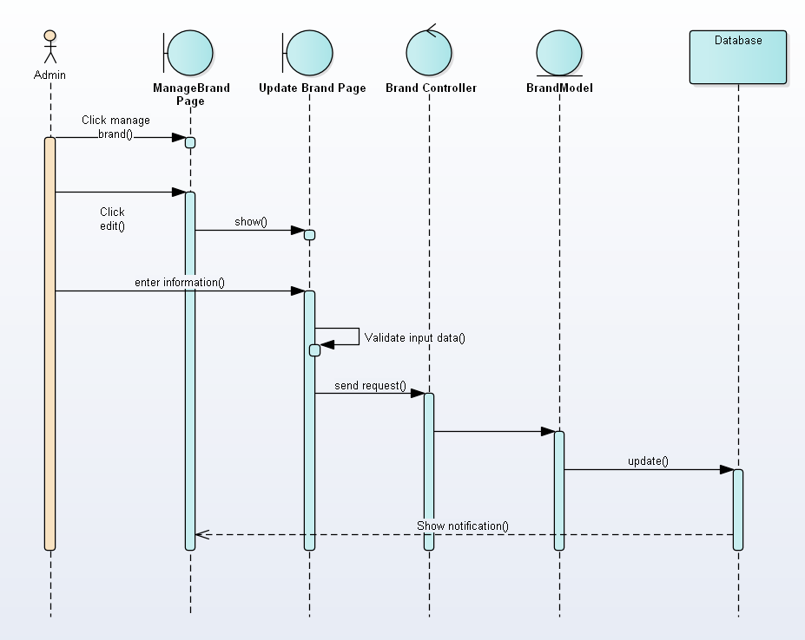

Figure 30: Edit brand sequence diagram

#### 4.2.15.3. Delete Brand

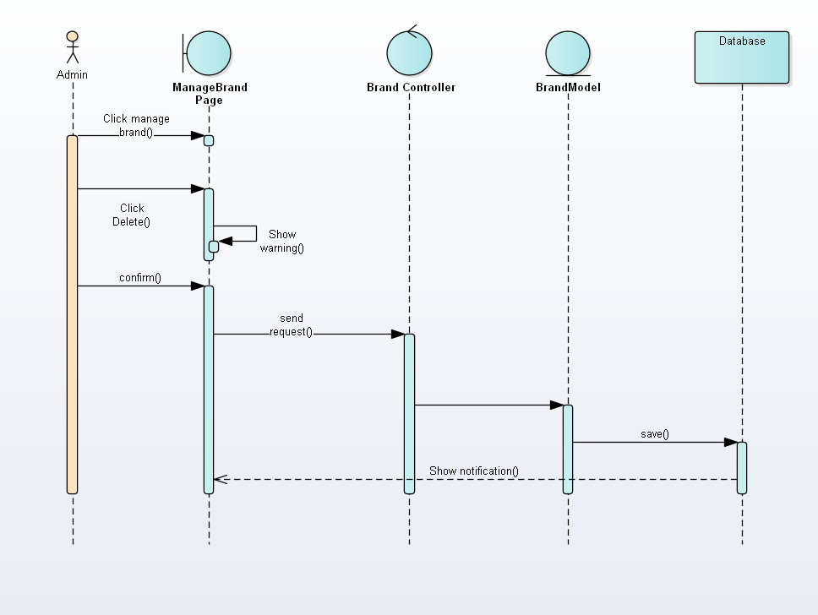

Figure 31: Delete brand sequence diagram

4.2.16. Search Pitches

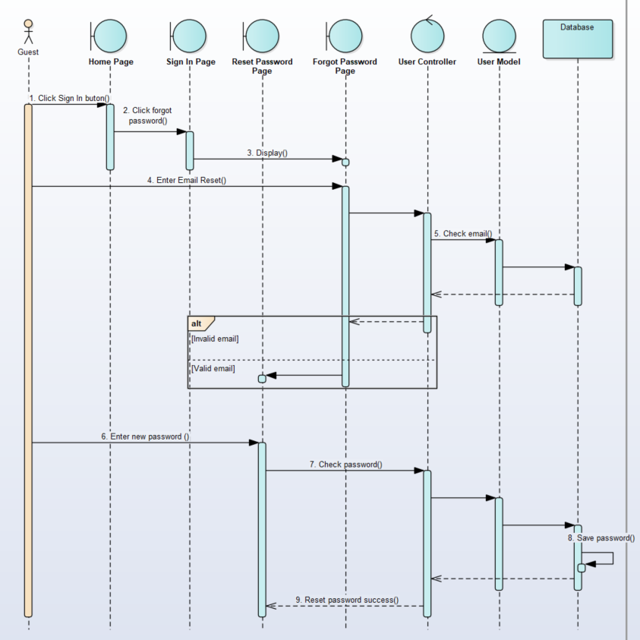

Figure 32: Search pitches sequence diagram

## 4.3. USER INTERFACE DESIGN

### 4.3.1. Home Page

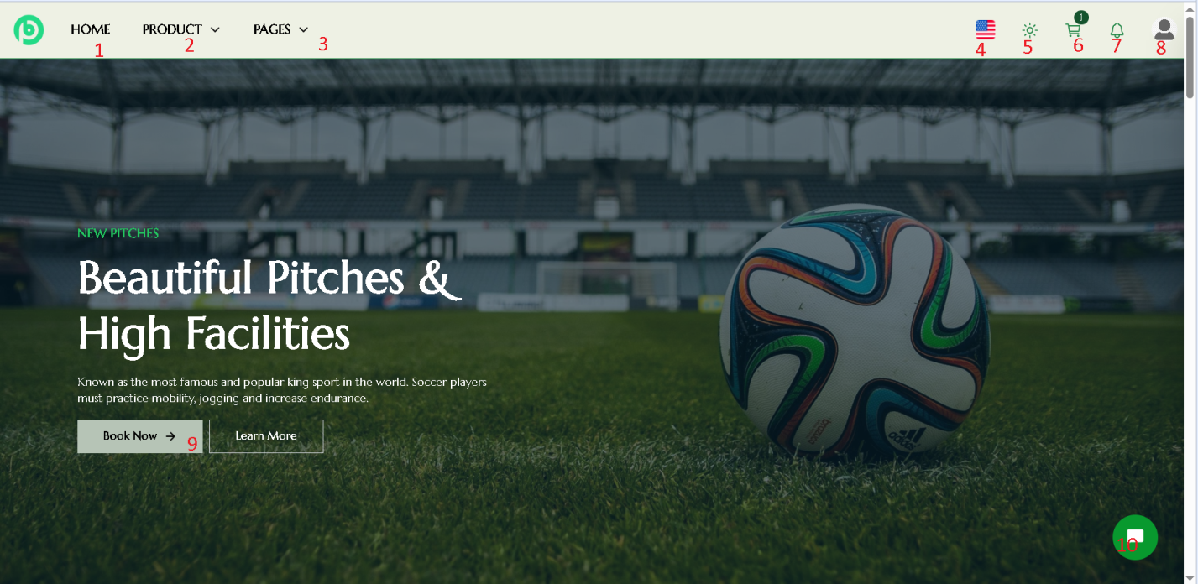

Figure 33: Home Page

* Number 1: Home Page
* Number 2: Booking Page & News
* Number 3: FAQ Page and Contact Page
* Number 4: Change Language
* Number 5: Change Dark mode
* Number 6: View Cart Order
* Number 7: View Notifications
* Number 8: User Menu
* Number 9: Pitches Page
* Number 10: Chat Bot

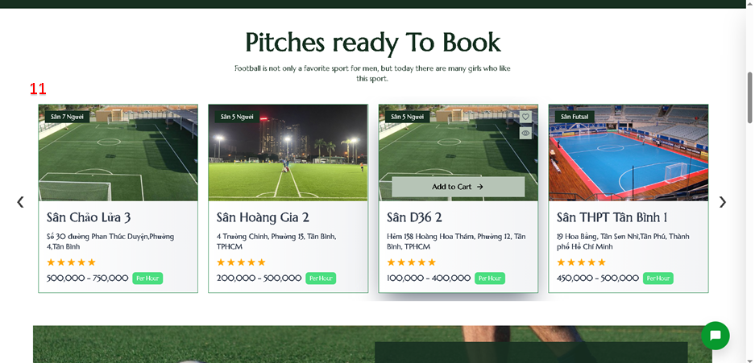

Figure 34: Home Page List of Pitches

* Number 11: List of Pitches

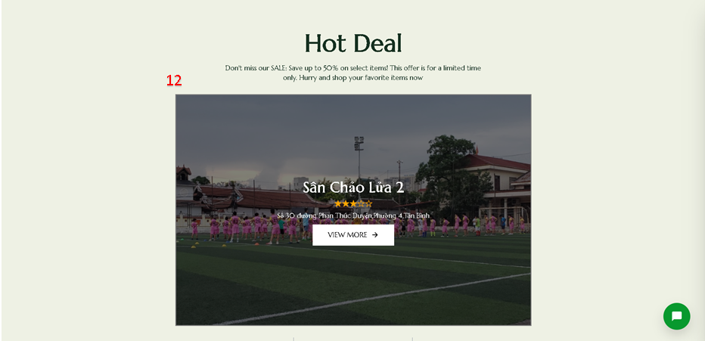

Figure 35: Home Page Hot Deal

* Number 12: Hot Pitch of the day

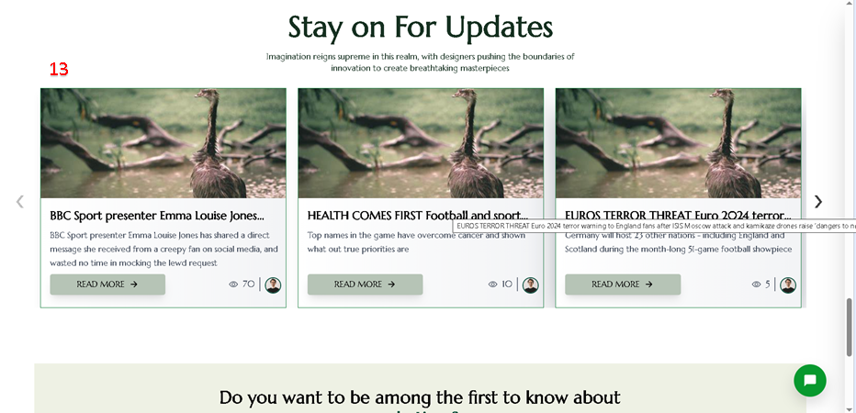

Figure 36: Home Page List of New

* Number 13: List New

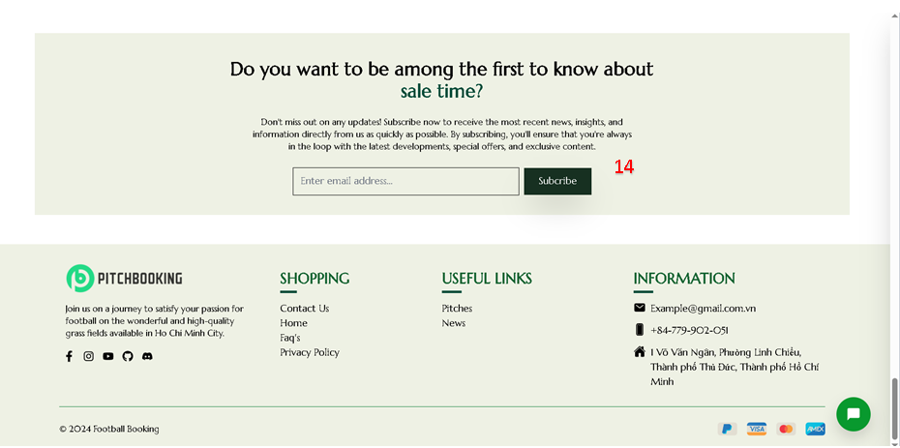

Figure 37: Home Page Contact by Email

* Number 14: Contact by email

### 4.3.2. Pitches Page

5

1

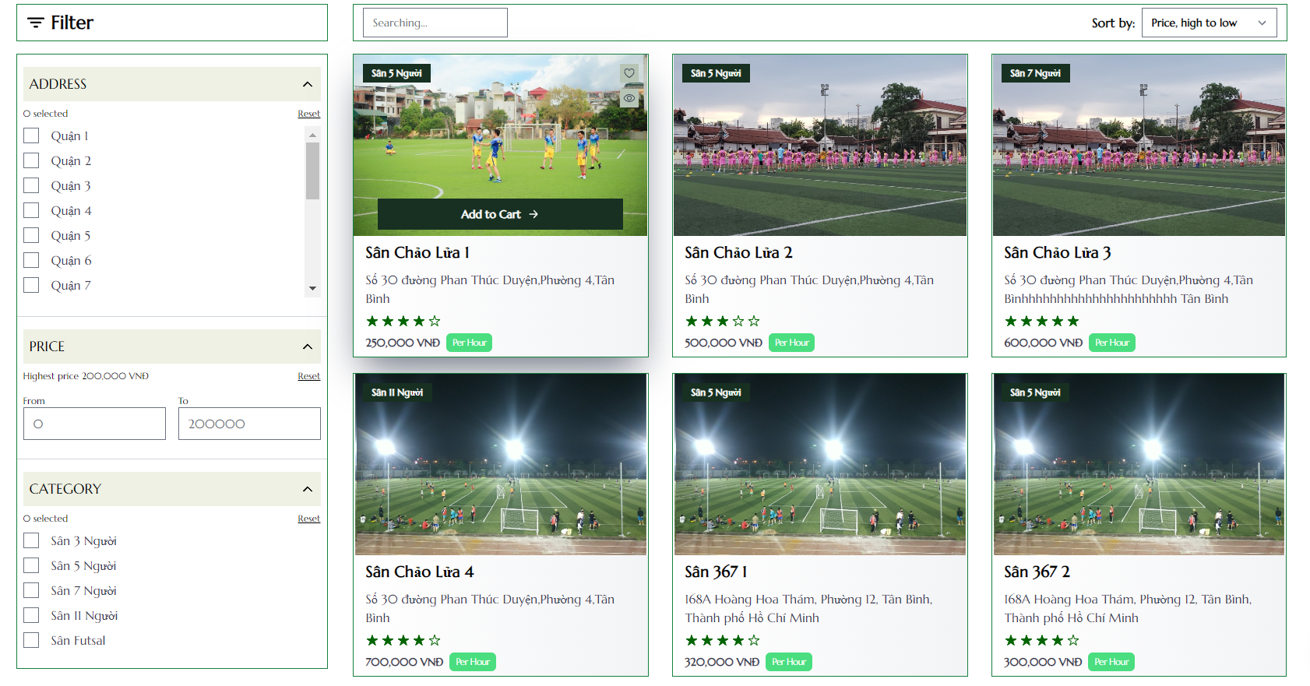

9

8

7

6

4

2

3

Figure 38: Pitches Page

* Number 1: Search pitches by name
* Number 2: Filter pitches by address
* Number 3: Filter pitches by price
* Number 4: Filter pitches by category6
* Number 5: Sort pitches follow conditions
* Number 6: Pitch card
* Number 7: View pitch detail
* Number 8: Add pitch to wish list
* Number 9: Quick view pitch information

### 4.3.3. Pitch Detail Page

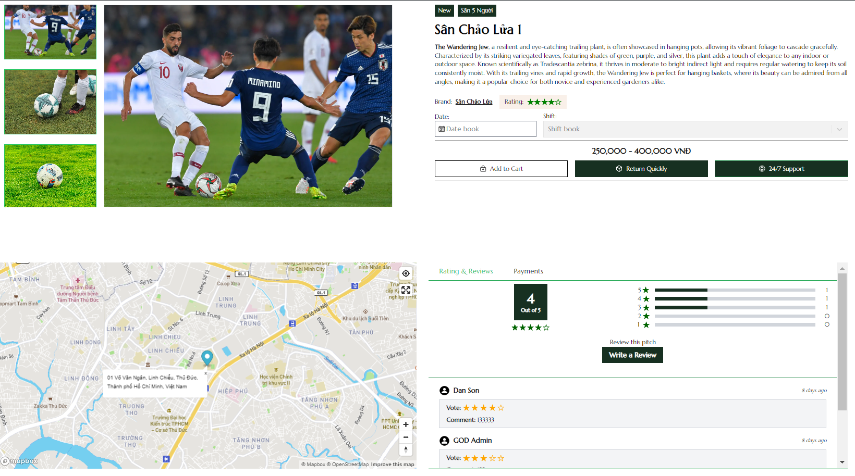

7

5

6

4

3

2

1

5

3

Figure 39: Pitch Detail Page

* Number 1: Pitch thumb and images
* Number 2: Select Date
* Number 3: Select Shift
* Number 4: Add to user cart
* Number 5: Pitch location on map
* Number 6: Review the pitch
* Number 7: Pitch rating and comment

### 4.3.4. FAQs

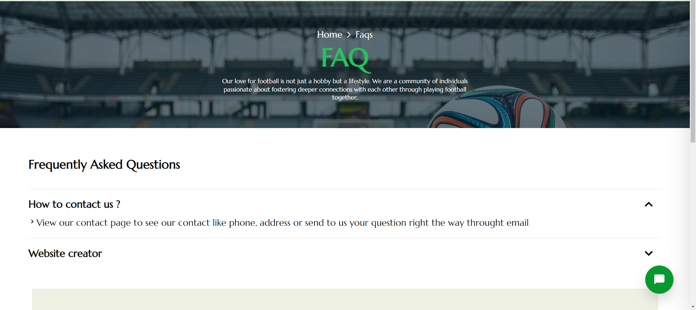

3

2

1

Figure 40: FAQs Page

* Number 1: Faq’s question title
* Number 2: Faq’s description
* Number 3: Button close or open faq’s description

### 4.3.4. Login/Sign Up Page



6

7

4

3

2

1

5

Figure 41: Sign In Page

* Number 1: Button show sign up as a user form
* Number 2: Button show sign up as a pitch owner
* Number 3: Input field for email to login
* Number 4: Input field for password to login
* Number 5: Button to login after fill up email and password
* Number 6: Button to login with a google account
* Number 7: Button to show your password

### 4.3.5. Personal Work space

#### 4.3.5.1. Manage Information

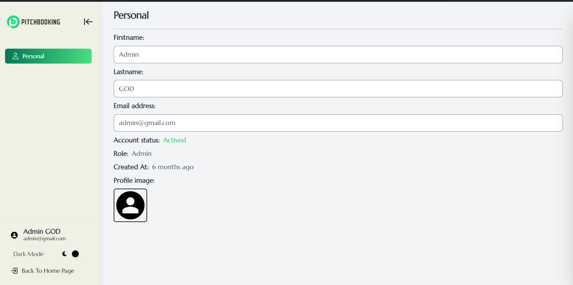

6

5

3

2

1

4

Figure 42: Manage Information Page

* Number 1: First name textbox
* Number 2: Last name textbox
* Number 3: Email address textbox
* Number 4: Image of user
* Number 5: Back to homepage
* Number 6: Dark mode button

#### 4.3.5.2. Booking histories

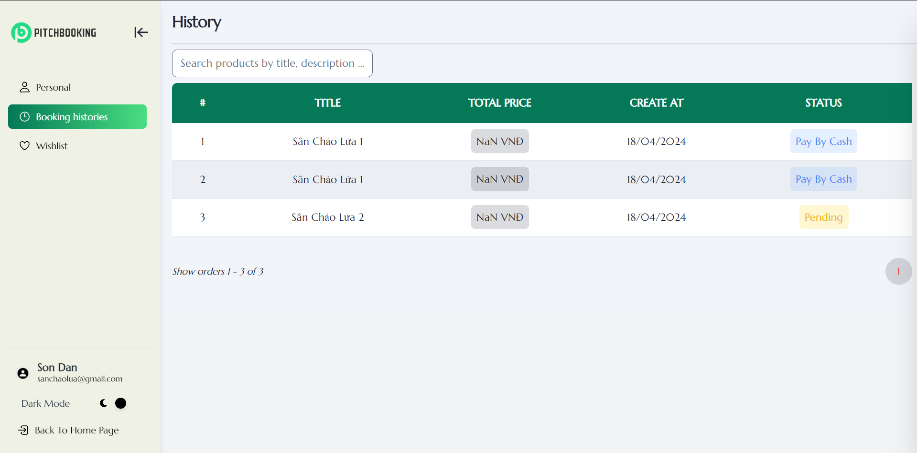

1

2

Figure 43: Booking Histories Page

* Number 1: Search history by name pitch
* Number 2: Detail of booking pitch

#### 4.3.5.3. Wish List

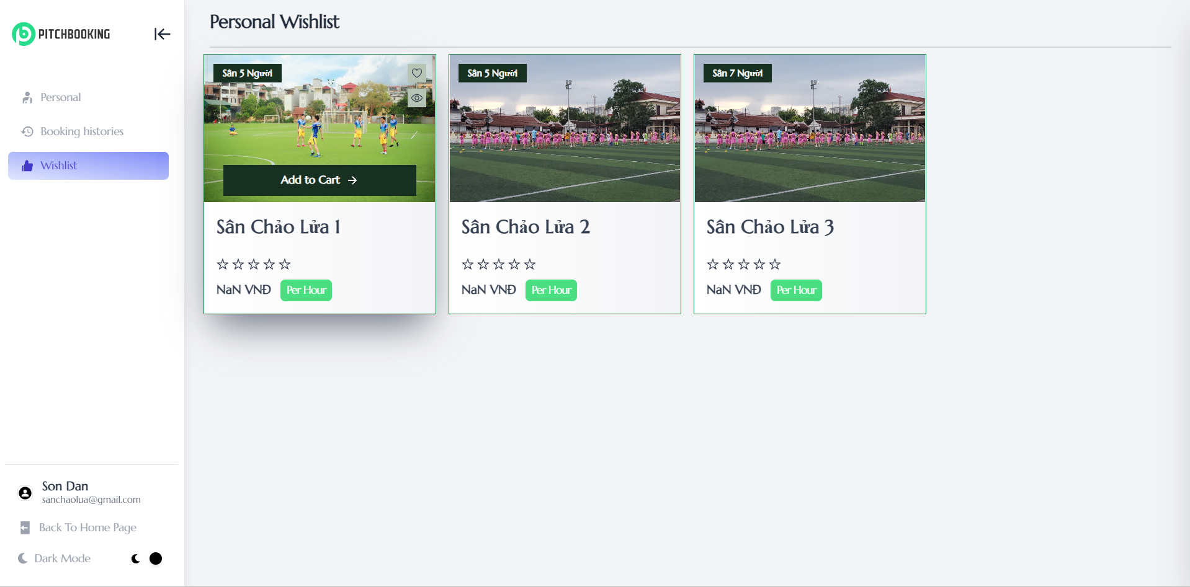

2

1

Figure 44: Wish List Page

* Number 1: Button remove pitch from wish list
* Number 2: Button navigate to pitch detail page

### 4.3.6. Admin Workspace

#### 4.3.6.1. Admin dashboard

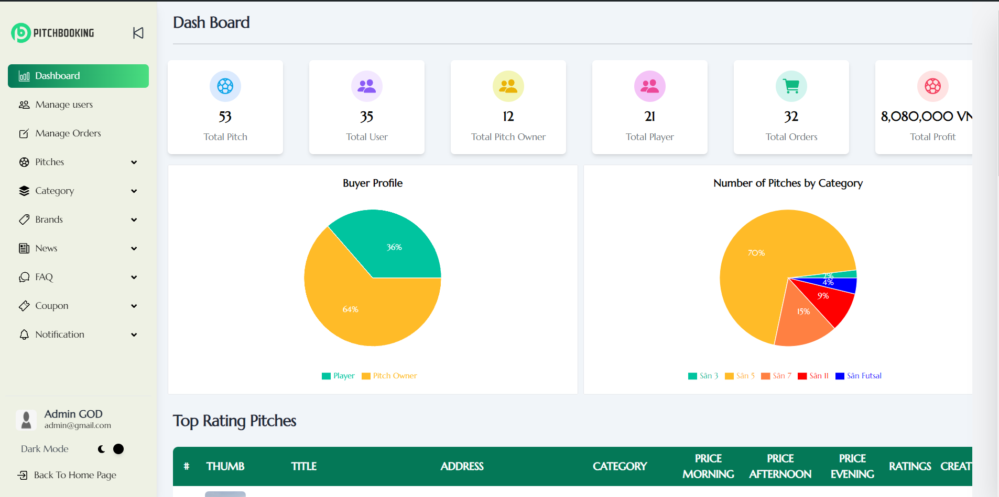

2

8

7

6

5

4

3

1

Figure 45: Admin Dashboard Page

* Number 1: Total pitch
* Number 2: Total user
* Number 3: Total pitch owner
* Number 4: Total player
* Number 5: Total Order
* Number 6: Total Profit
* Number 7: Statistics on the type of field bettors
* Number 8: Percentage statistics for all types of courts

#### 4.3.6.2. Manage User

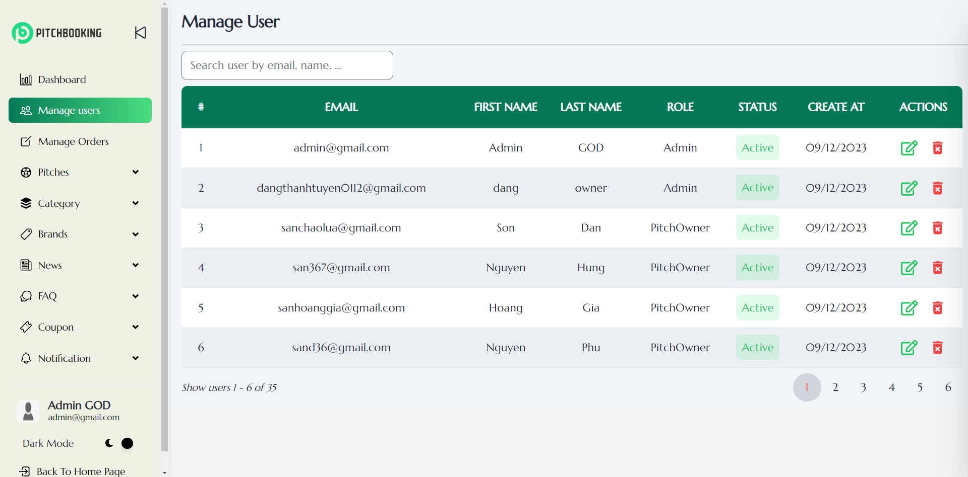

3

1

2

Figure 46: Admin Manage User Page

* Number 1: Search User by name, email
* Number 2: User list
* Number 3: Edit user

#### 4.3.6.3. Manage Order

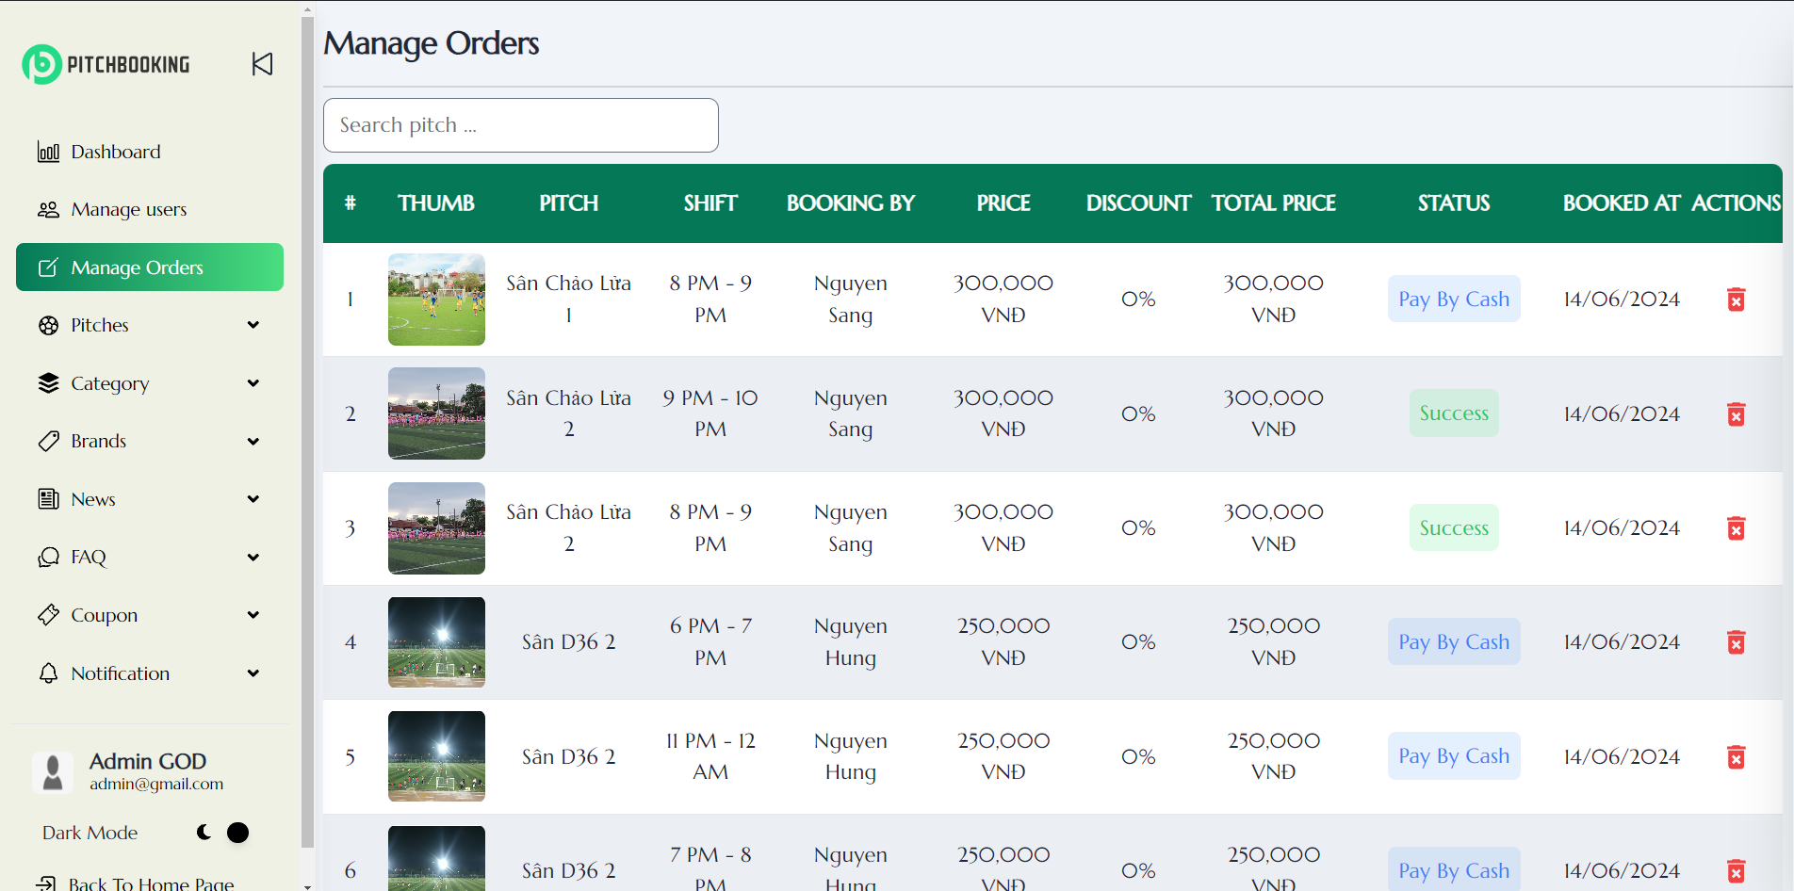

1

3

2

Figure 47: Admin Manage Order Page

* Number 1: Search Order by pitch name
* Number 2: Order list
* Number 3: Delete Order

#### 4.3.6.4. Pitches

##### 4.3.6.4.1. Create Pitch

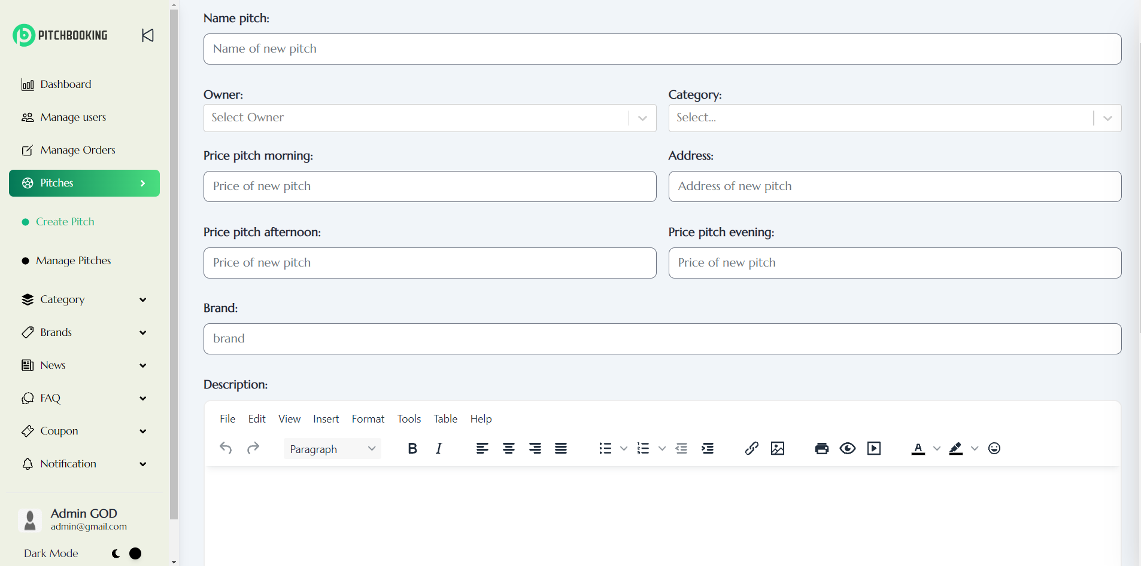

8

7

5

3

6

4

2

1

9

Figure 48: Admin Create Pitch Page 1

* Number 1: Name pitch
* Number 2: Owner name
* Number 3: Pitch category
* Number 4: Price of pitch in the morning
* Number 5: Address
* Number 6: Price of pitch in the afternoon
* Number 7: Price of pitch in the evening
* Number 8: Brand Name
* Number 9: Pitch description

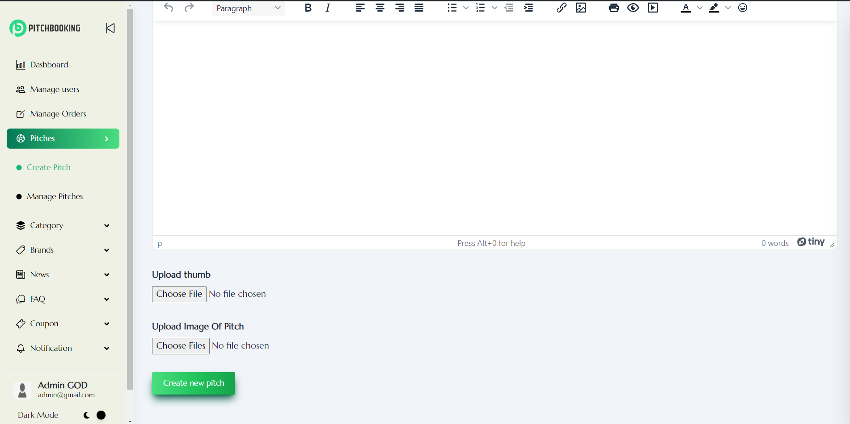

12

11

10

Figure 49: Admin Create Pitch Page 2

* Number 10: Pitch thumb
* Number 11: Pitch Image
* Number 12: Create new pitch

##### 4.3.6.4.2. Manage Pitches

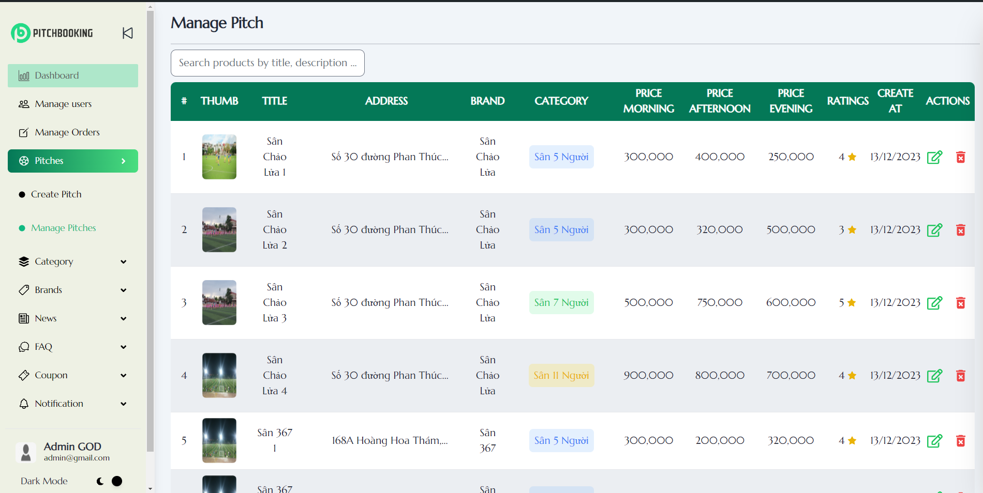

1

4

2

3

Figure 50: Admin Manage Pitches Page

* Number 1: Search Pitch by title
* Number 2: Pitch list
* Number 3: Edit pitch
* Number 4: Delete pitch

#### 4.3.6.5. Category

##### 4.3.6.5.1. Create Category

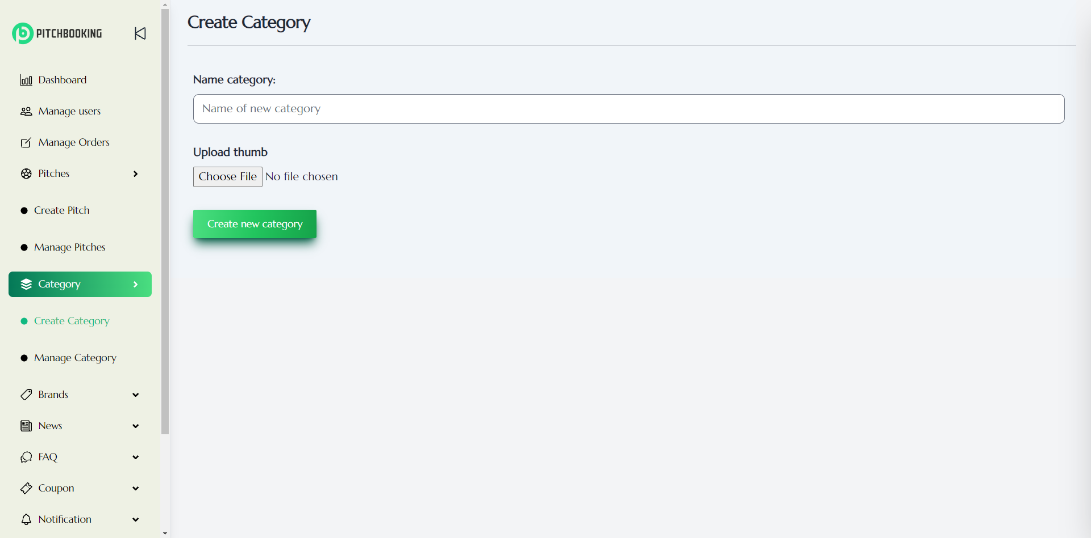

1

2

3

Figure 51: Admin create category page

* Number 1: Name category
* Number 2: Category thumb
* Number 3: Create new Category

##### 4.3.6.5.2. Manage Category

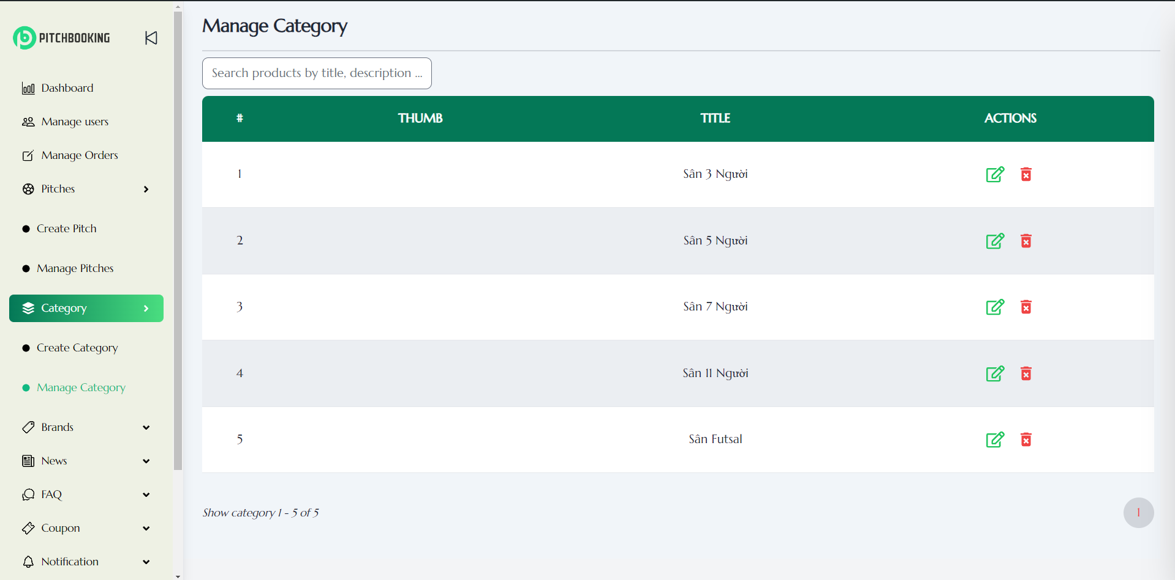

5

3

4

2

1

Figure 52: Admin Manage Category Page

* Number 1: Search Category by title
* Number 2: Category list
* Number 3: Edit Category
* Number 4: Delete category
* Number 5: Pagination

##### 4.3.6.5.3. Update Category

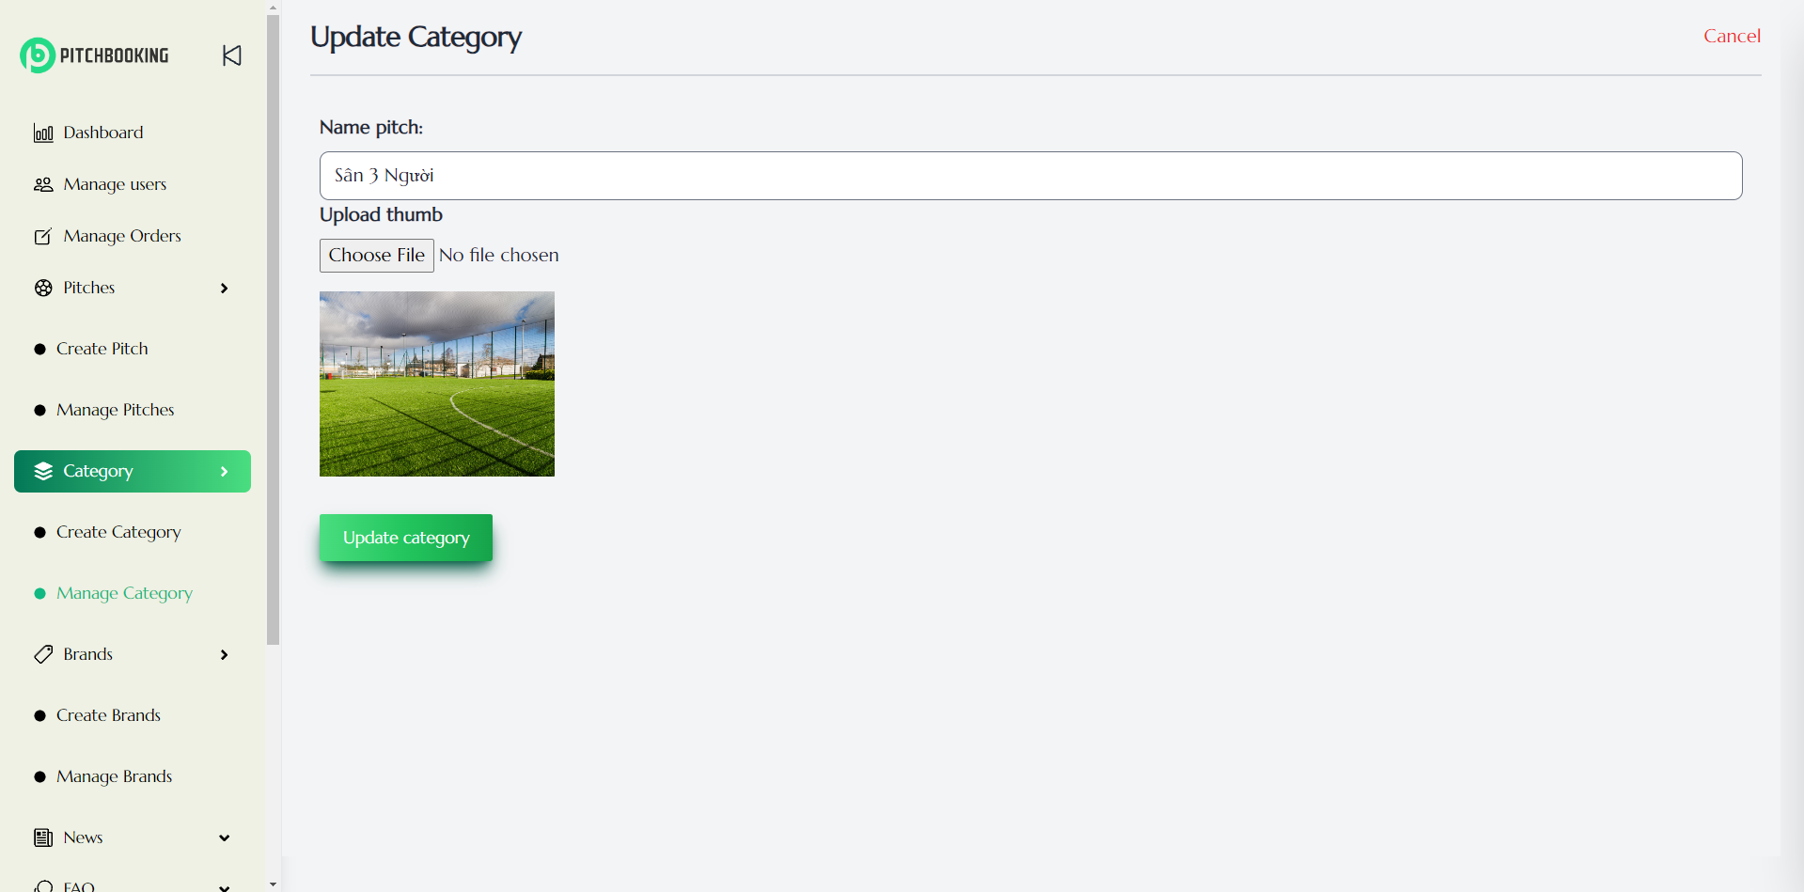

2

1

Figure 53: Admin Update Category Page

* Number 1: Category Name
* Number 2: Category Thumbnail name

#### 4.3.6.6. Brands

##### 4.3.6.6.1. Create Brands

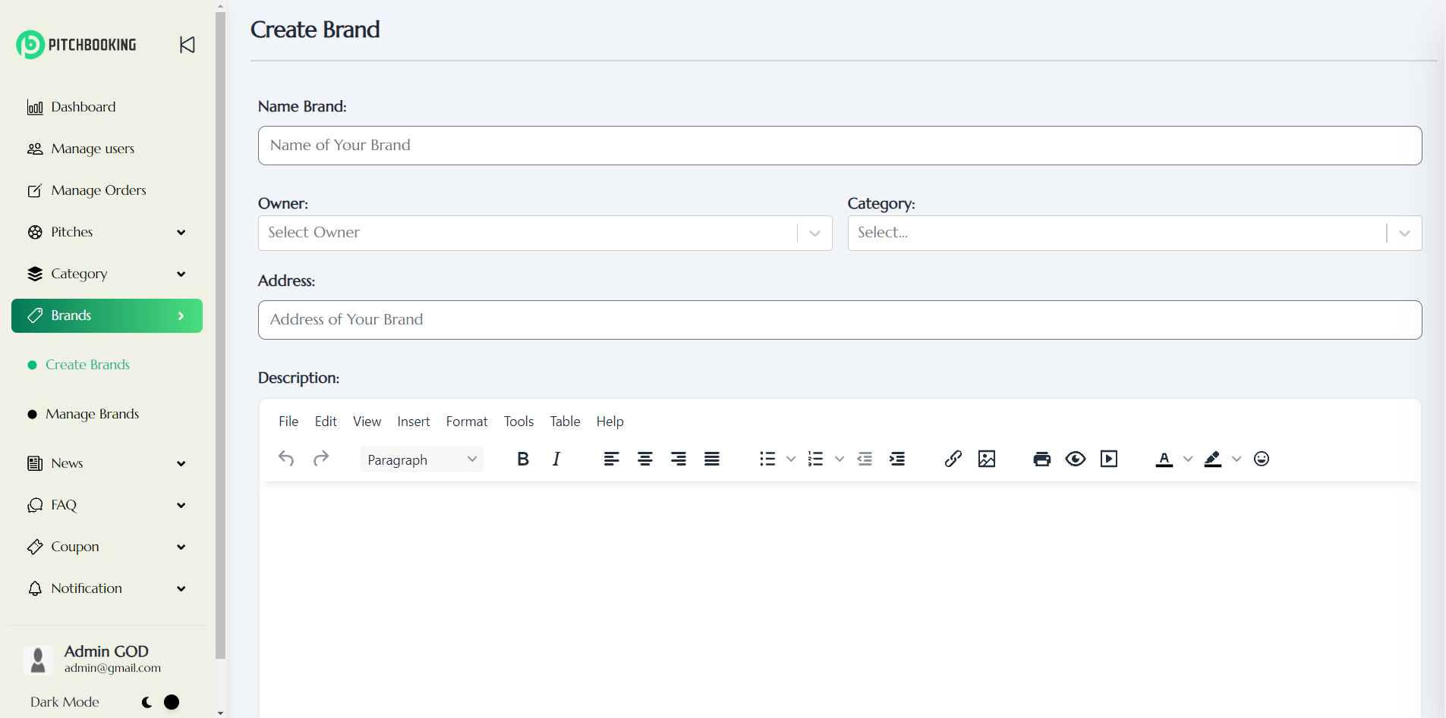

1

4

3

2

5

Figure 54: Admin Create Brand Page 1

* Number 1: Brand Name
* Number 2: Owner name
* Number 3: Category
* Number 4: Brand Address
* Number 5: Brand Description

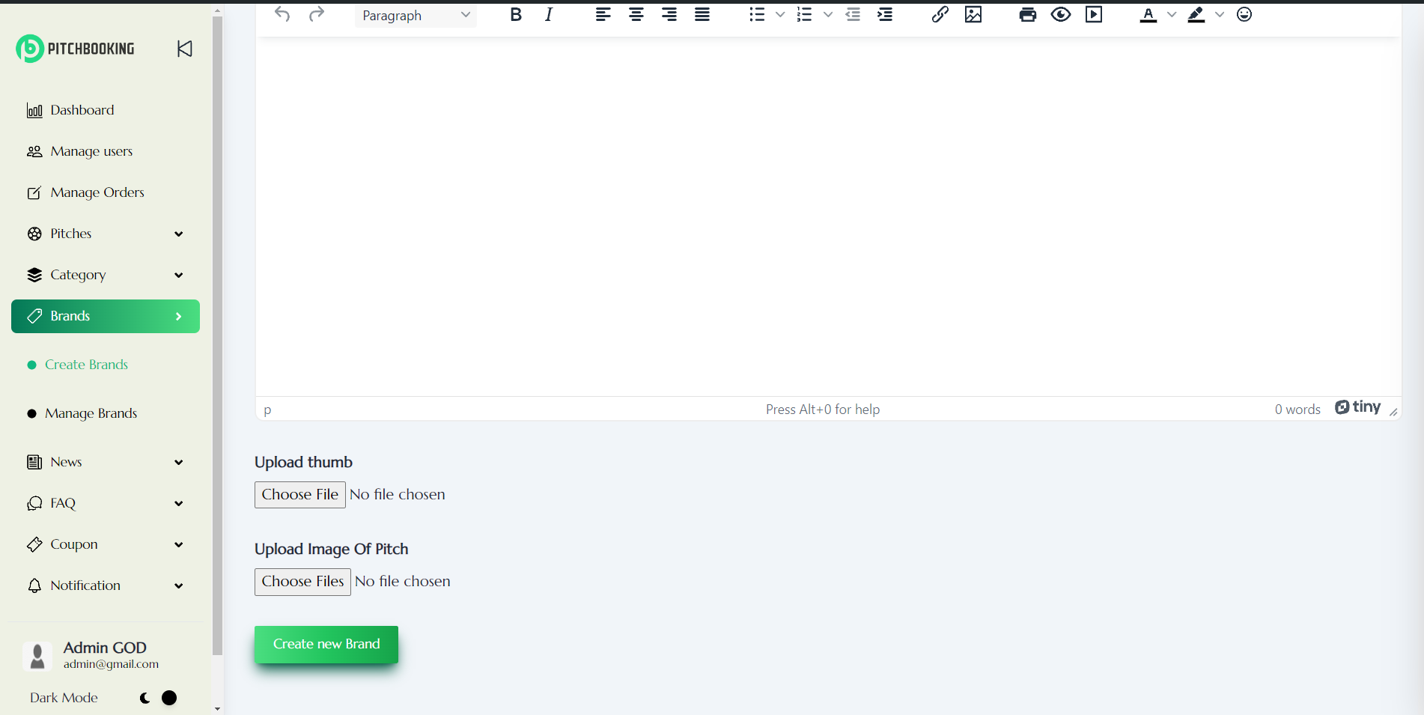

8

7

6

Figure 55: Admin Create Brand Page 2

* Number 6: Brand thumb
* Number 7: Brand Image
* Number 8: Create new Brand

##### 4.3.6.6.2. Manage Brands

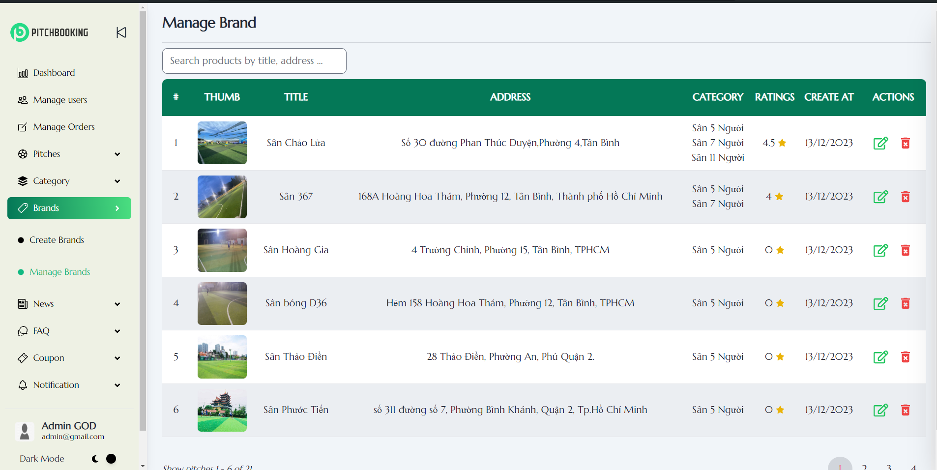

2

1

4

3

Figure 56: Admin Manage Brands Page

* Number 1: Search Brand by title
* Number 2: Brand list
* Number 3: Edit Brand
* Number 4: Delete Brand

#### 4.3.6.7. News

##### 4.3.6.7.1. Create News

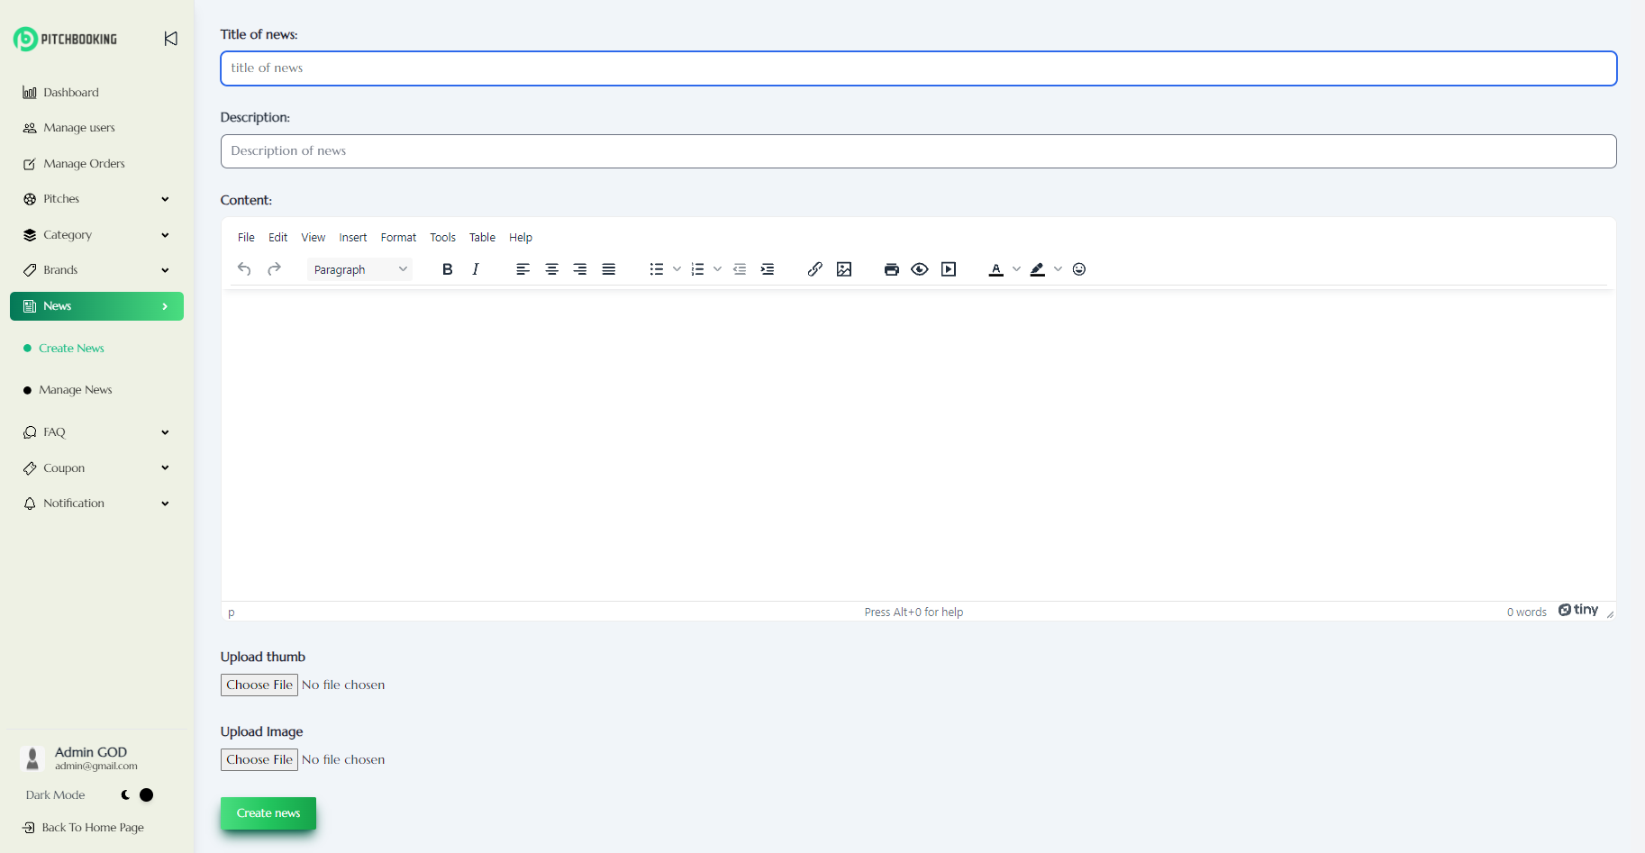

6

5

4

3

2

1

Figure 57: Admin Create News Page

* Number 1: Input field for title of the new
* Number 2: Input field for description of the new
* Number 3: Text area for content of the new
* Number 4: Button to upload thumbnail of the new
* Number 5: Button to upload image of the new
* Number 6: Button to confirm create a new article

##### 4.3.6.7.2. Manage News

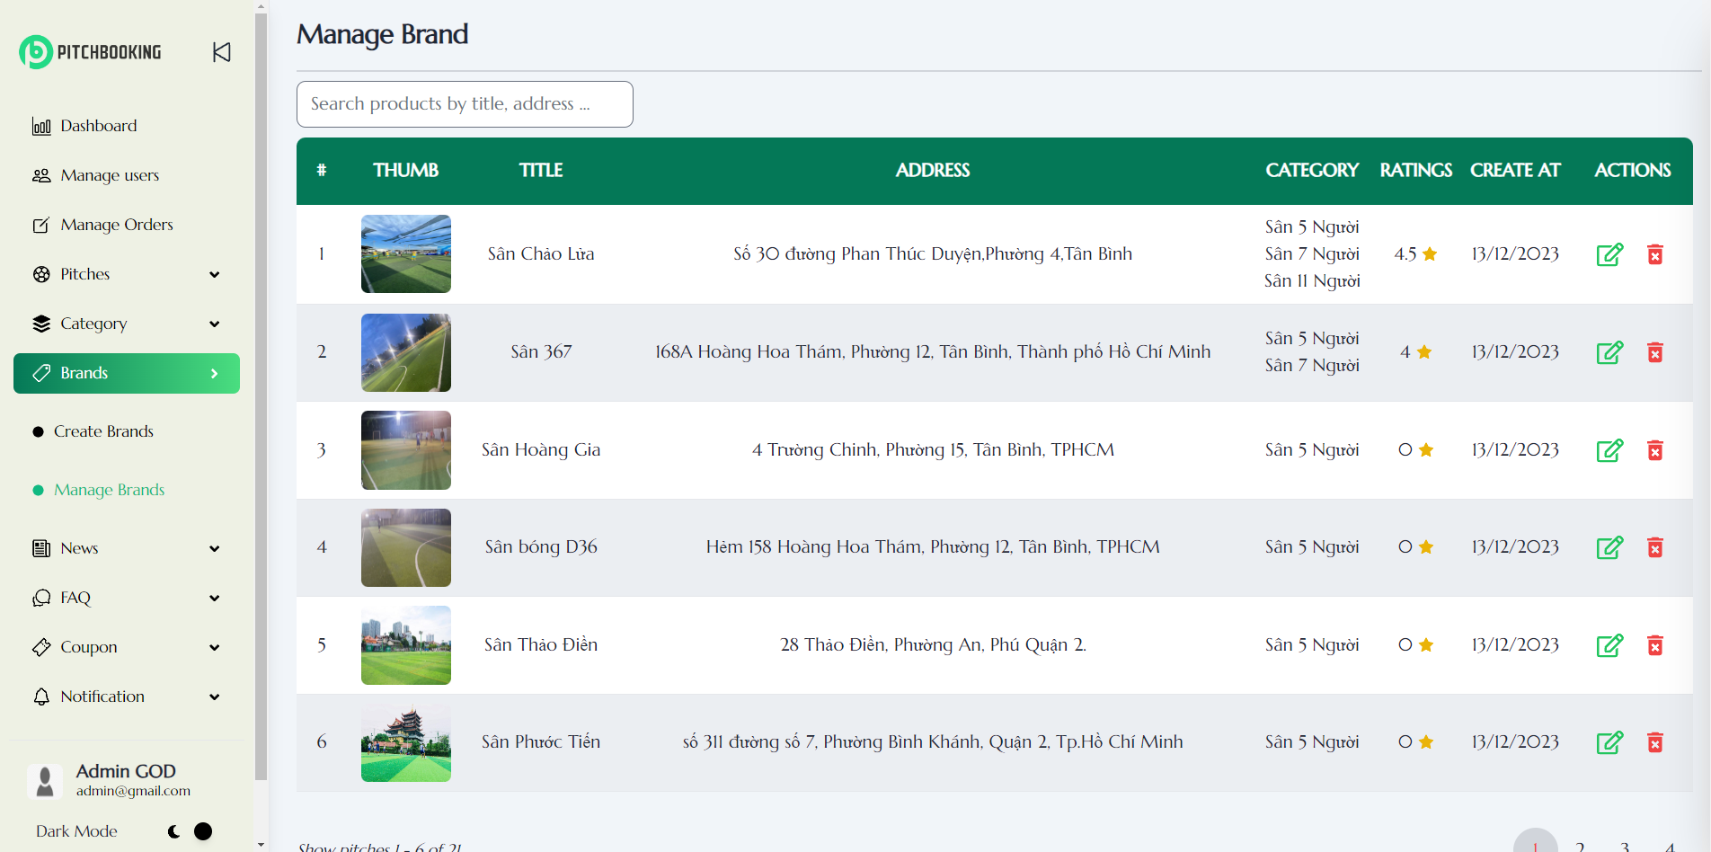

4

2

3

1

Figure 58: Admin Manage News Page

* Number 1: Input field for search new by title or description
* Number 2: Button to update new information
* Number 3: Button to delete new
* Number 4: Pagination

#### 4.3.6.8. FAQ’s

##### 4.3.6.8.1. Create FAQ’s

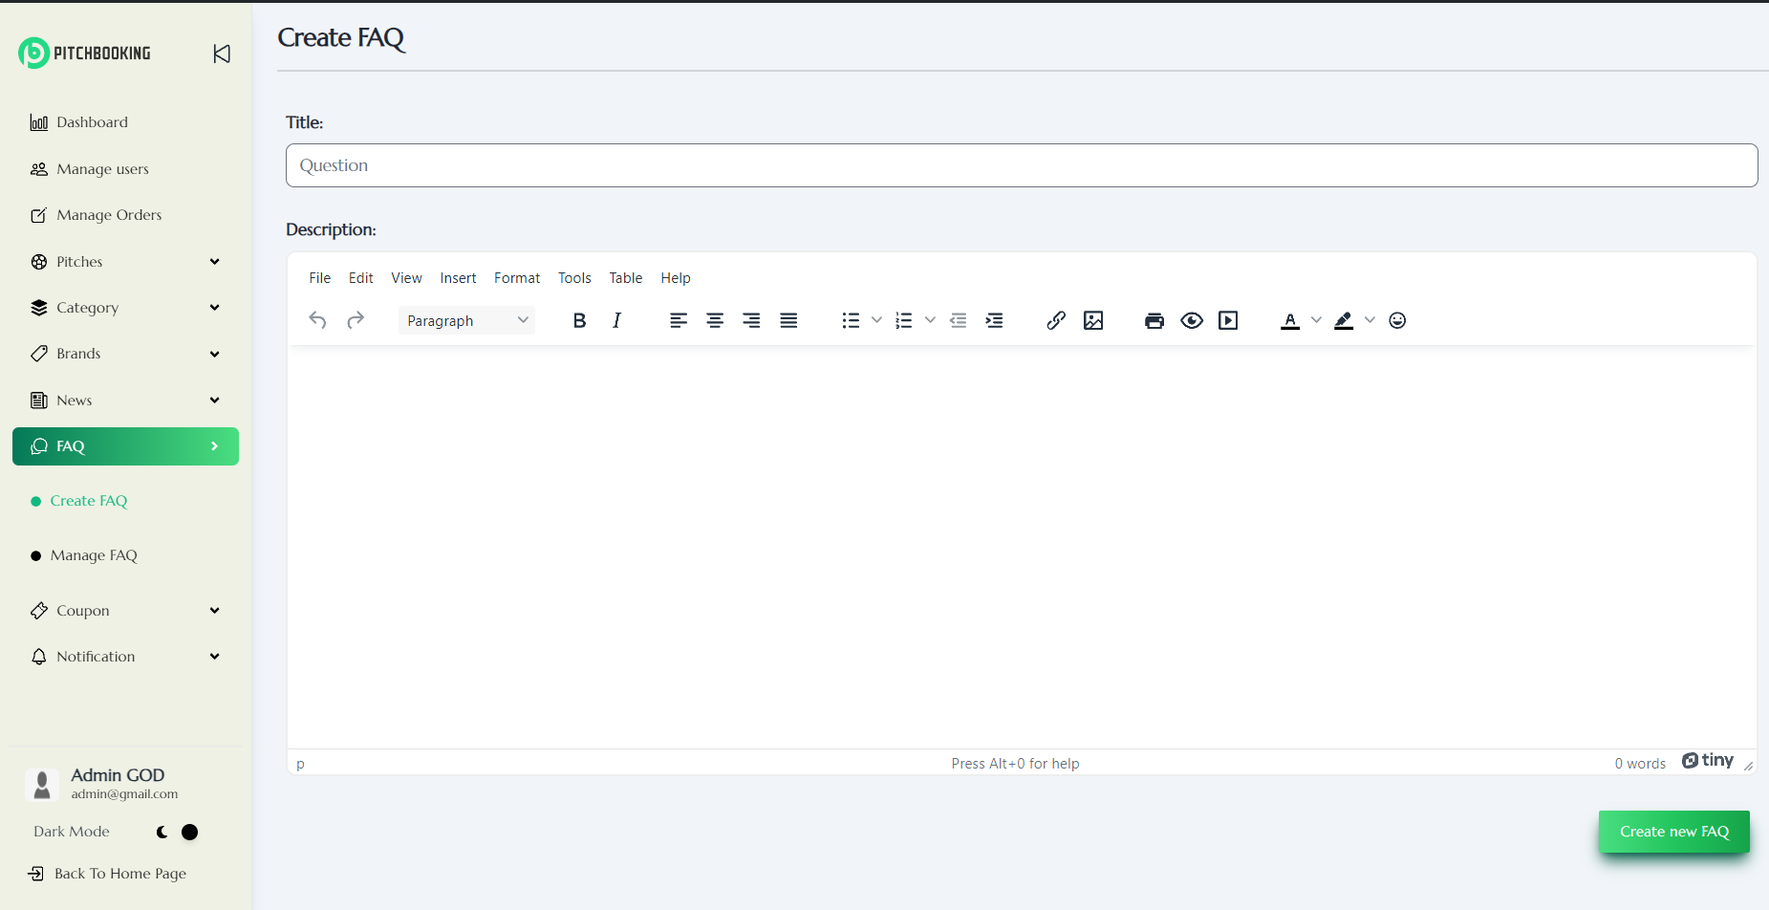

3

1

2

Figure 59: Admin Create FAQ’s Page

* Number 1: Input field for Title of Faq’s
* Number 2: Text area for description of Faq’s
* Number 3: Button to confirm create a new question

##### 4.3.6.8.2. Manage FAQ’s

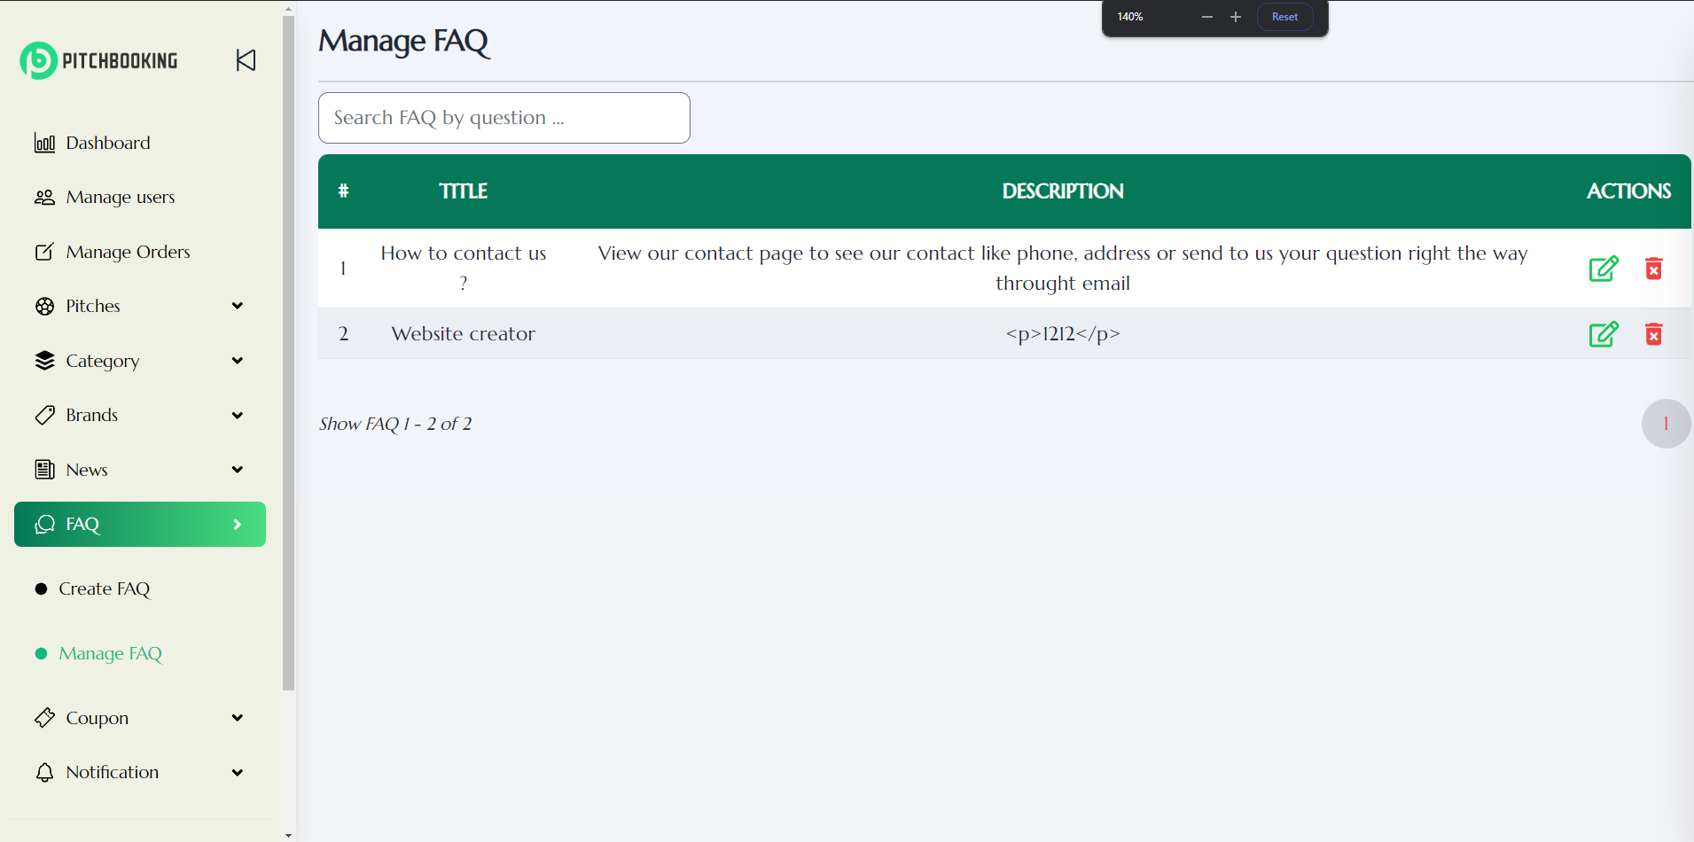

2

3

4

1

Figure 60: Manage FAQ’s Page

* Number 1: Input field for search Faq’s by title
* Number 2: Button update information of the question
* Number 3: Button to delete the question
* Number 4: Pagination

#### 4.3.6.9. Coupon

##### 4.3.6.9.1. Create Coupon

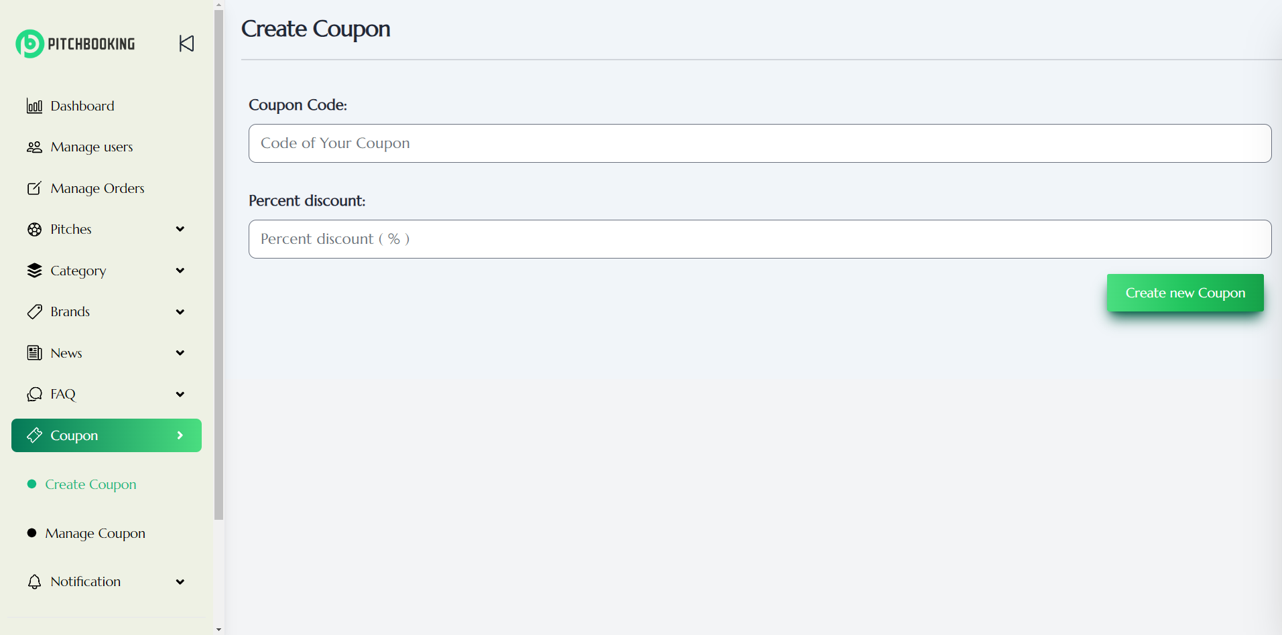

1

2

3

Figure 61: Admin Create Coupon Page

* Number 1: Input field for coupon code
* Number 2: Input field for coupon percentage discount
* Number 3: Button confirm create a new coupon

##### 4.3.6.9.2. Manage Coupon

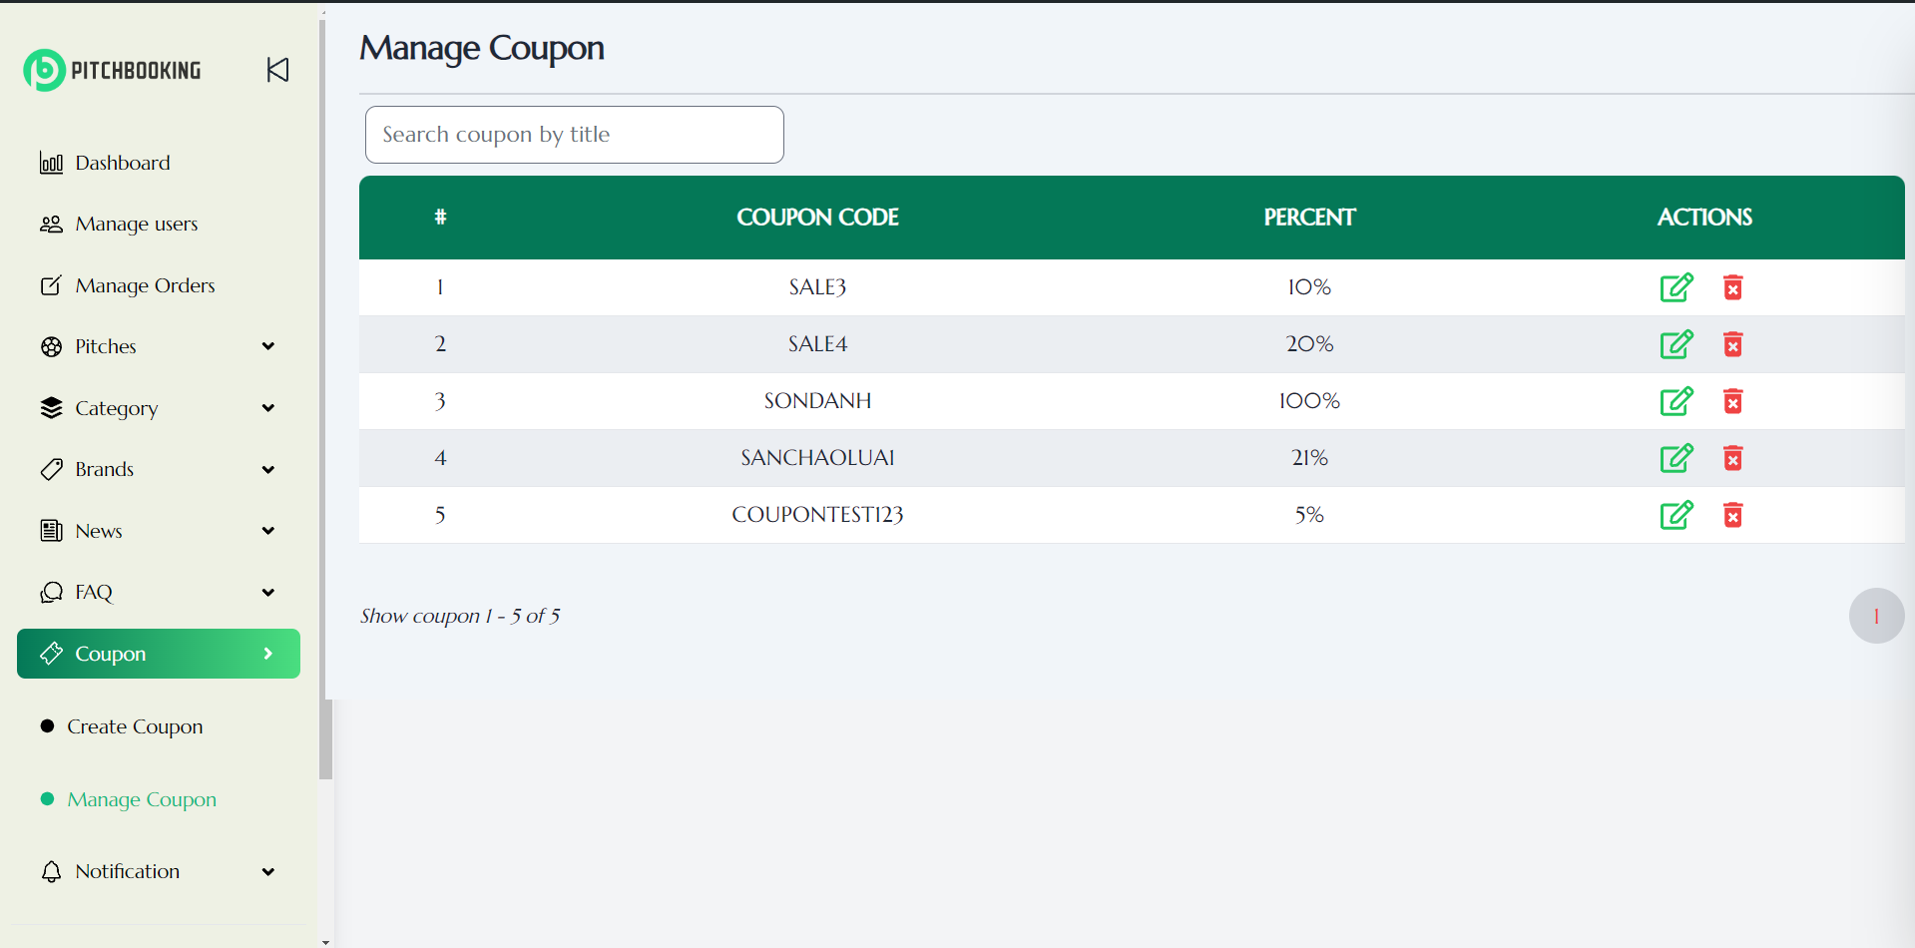

2

3

1

4

Figure 62: Admin Manage Coupon Page

* Number 1: Input field for searching coupon by code
* Number 2: Button to update coupon information
* Number 3: Button to delete coupon
* Number 4: Pagination

#### 4.3.6.10. Notification

##### 4.3.6.10.1. Create Notification

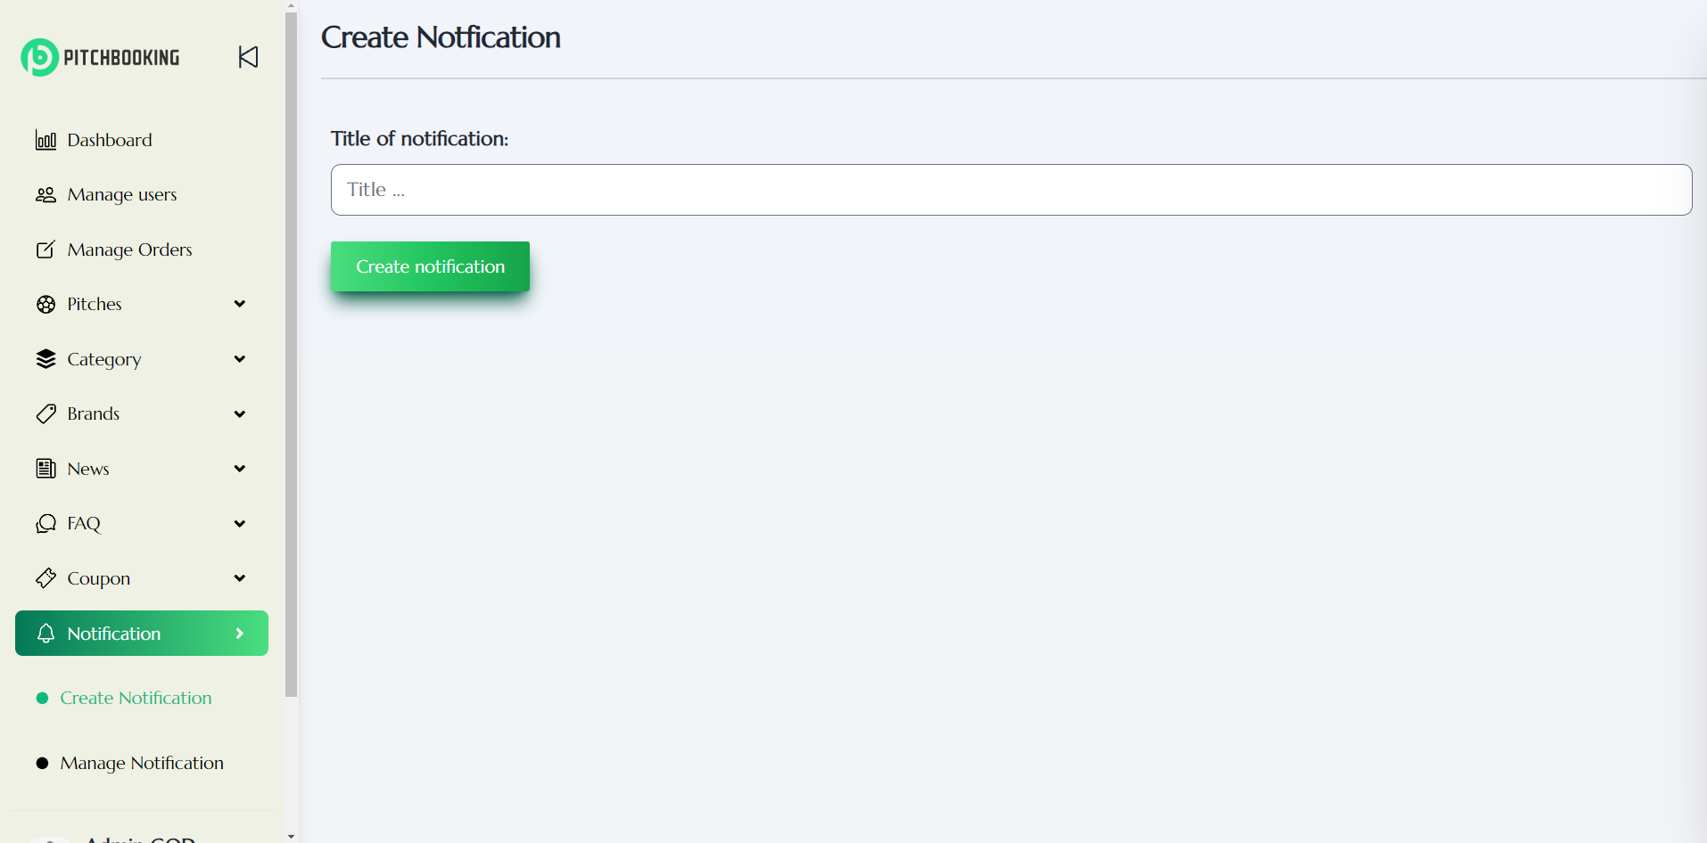Figure 63: Admin Create Notification Page

1

2

* Number 1: Input field for notification title
* Number 2: Button to confirm create a new notification

##### 4.3.6.10.2. Manage Notification

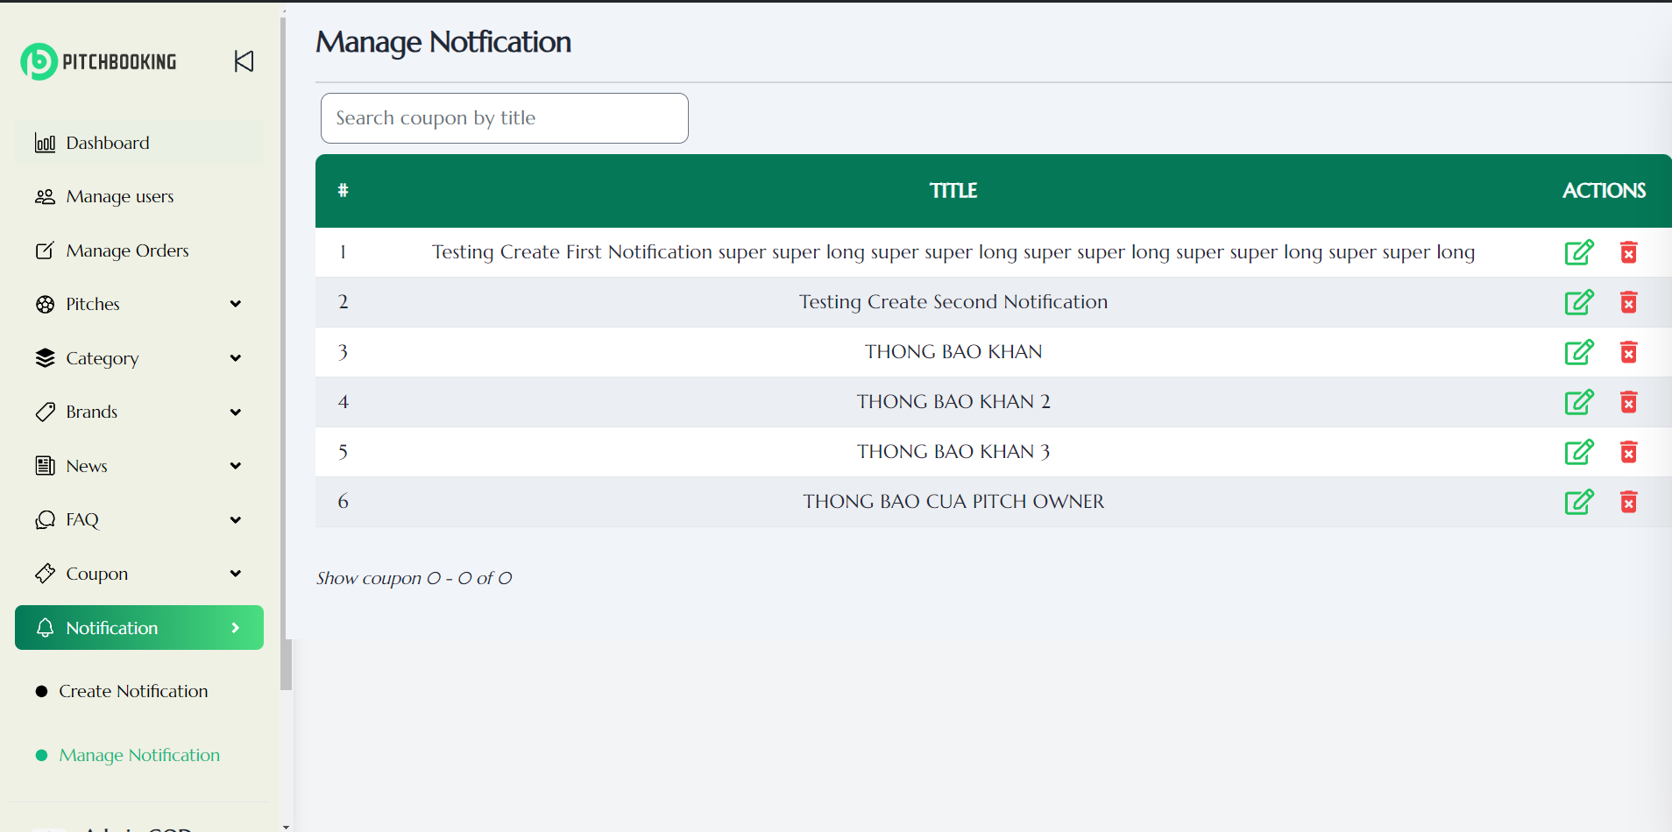

2

3

1

Figure 64: Admin Manage Notification Page

* Number 1: Input field for searching coupon by title
* Number 2: Button to update notification information
* Number 3: Button to delete notification

### 4.3.7. Pitch Owner Workspace

#### 4.3.7.1. Pitches

##### 4.3.7.1.1. Create Pitch

1

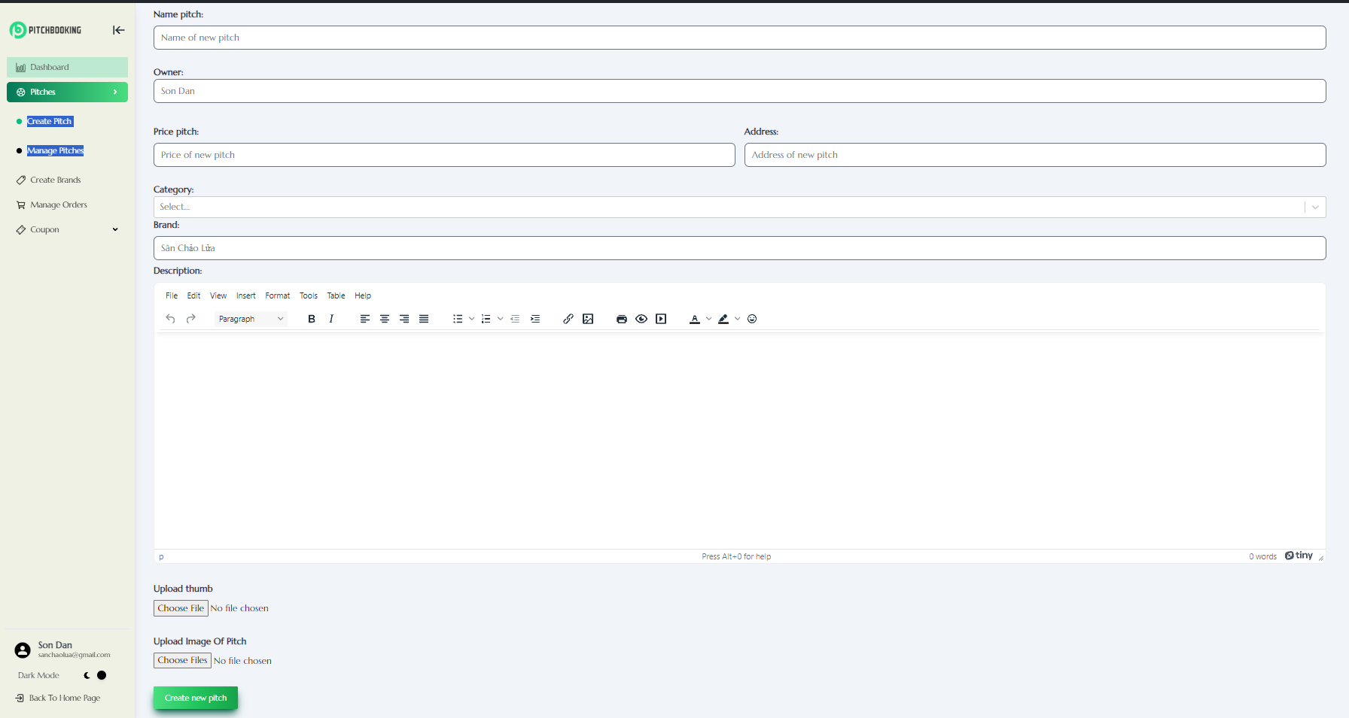

8

9

5

6

4

3

2

10

7

Figure 65: Pitch Owner Create Pitch Page

* Number 1: Name pitch
* Number 2: Owner
* Number 3: Price pitch
* Number 4: Address
* Number 5: Category
* Number 6: Brand
* Number 7: Description
* Number 8: Upload Thumbnail
* Number 9: Update Image
* Number 10: Button Confirm

##### 4.3.7.1.2. Manage Pitch

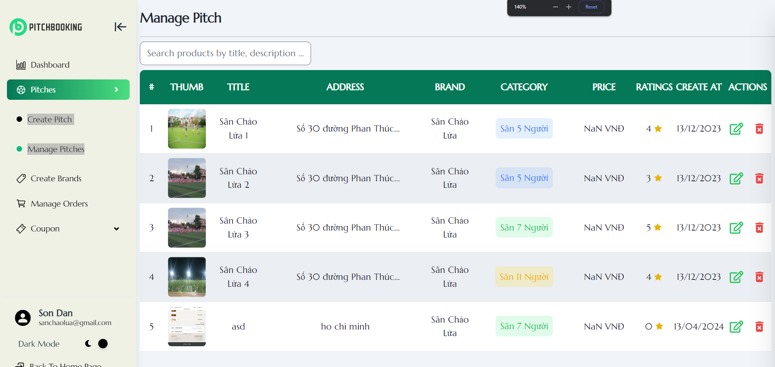

2

3

1

Figure 66: Pitch Owner Manage Pitch Page

* Number 1: Search pitch by name
* Number 2: Button update pitch information
* Number 3: Button delete pitch

#### 4.3.7.2. Create Brand

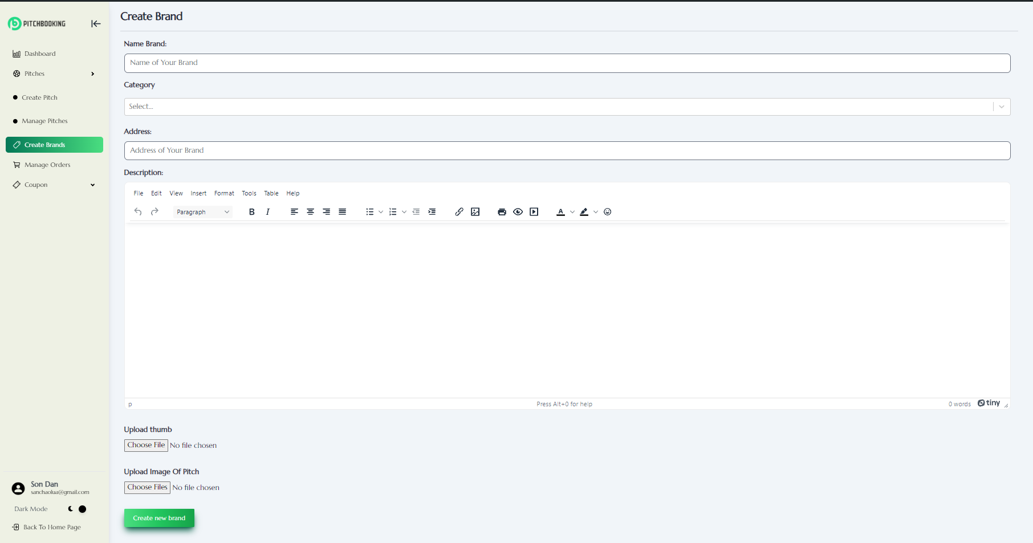

7

5

6

2

3

1

4

Figure 67: Pitch Owner Create Brand Page

* Number 1: Name brand
* Number 2: Category
* Number 3: Address
* Number 4: Description
* Number 5: Upload Thumbnail
* Number 6: Update Image
* Number 7: Button Confirm

#### 4.3.7.3. Manage Orders

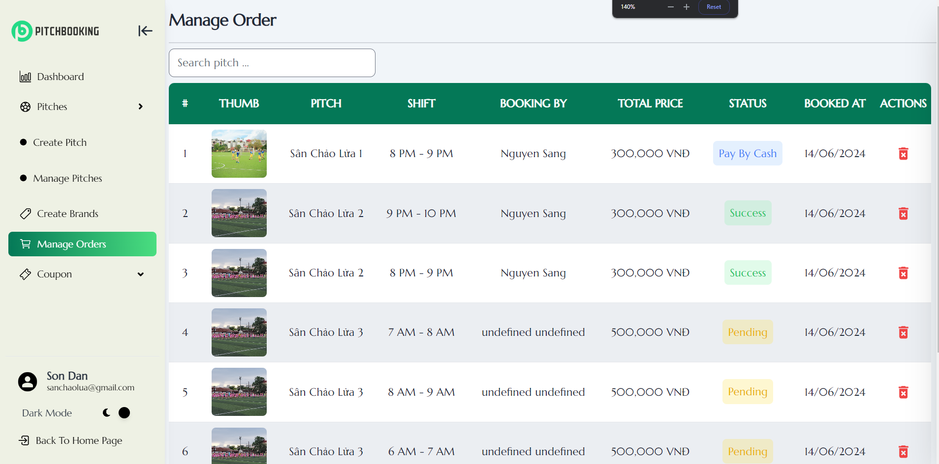

2

1

Figure 68: Pitch Owner Manage Order Page

* Number 1: Search order by name pitch
* Number 2: Delete order

#### 4.3.7.4. Manage Coupon

##### 4.3.7.4.1. Create Coupon

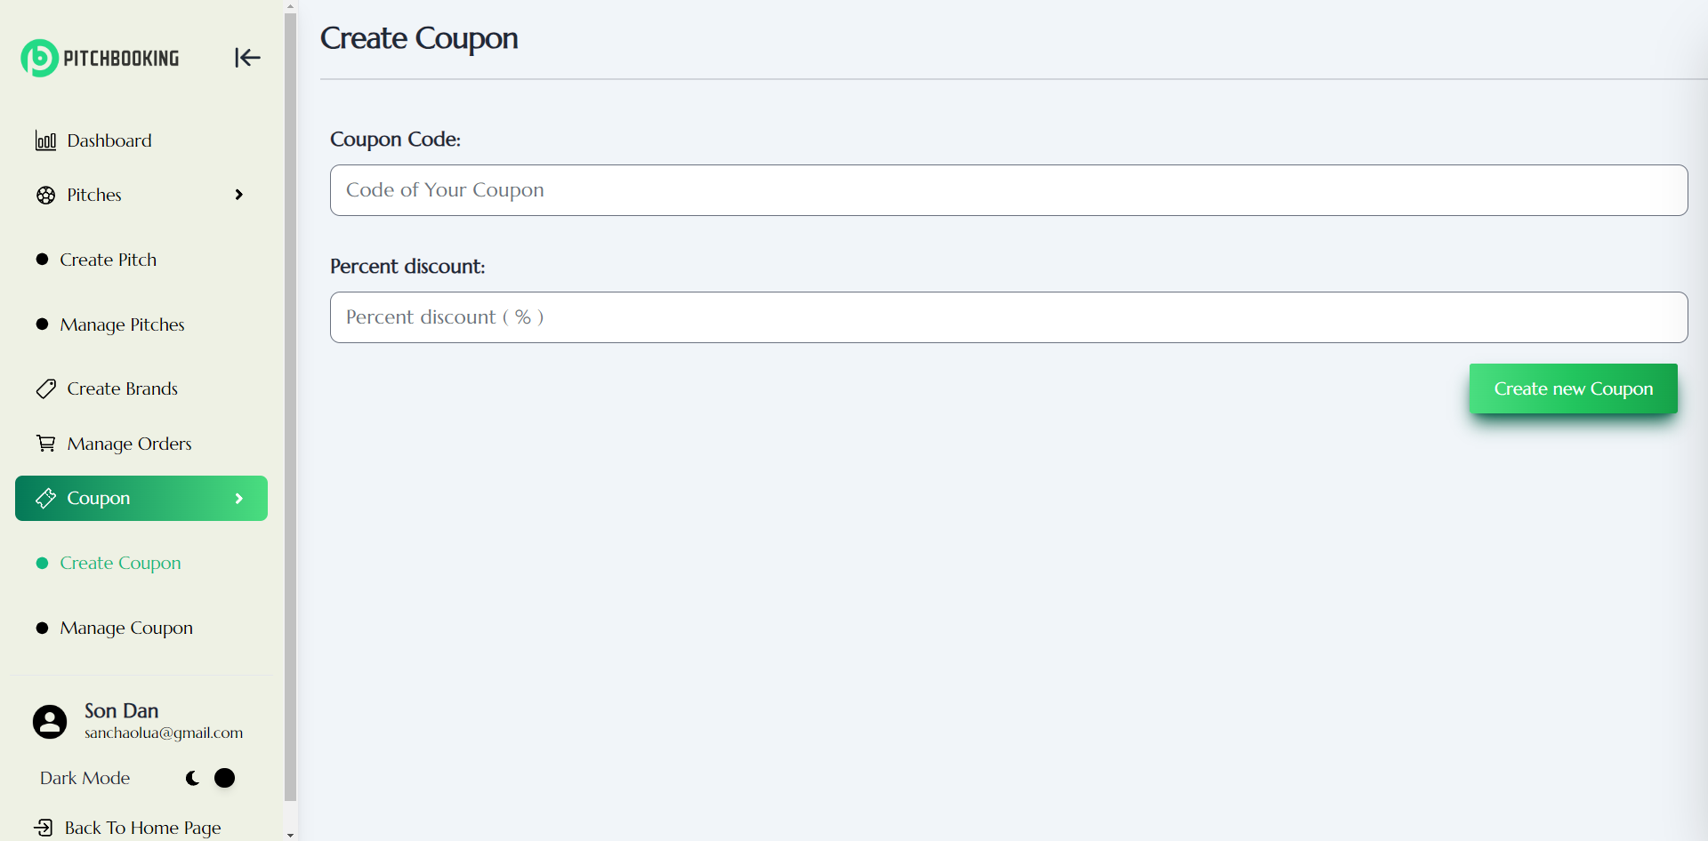

1

3

2

Figure 69: Pitch Owner Create Coupon Page

* Number 1: Input field for coupon code
* Number 2: Input field for coupon percentage discount
* Number 3: Button confirm create a new coupon

##### 4.3.7.4.2. Manage Coupon

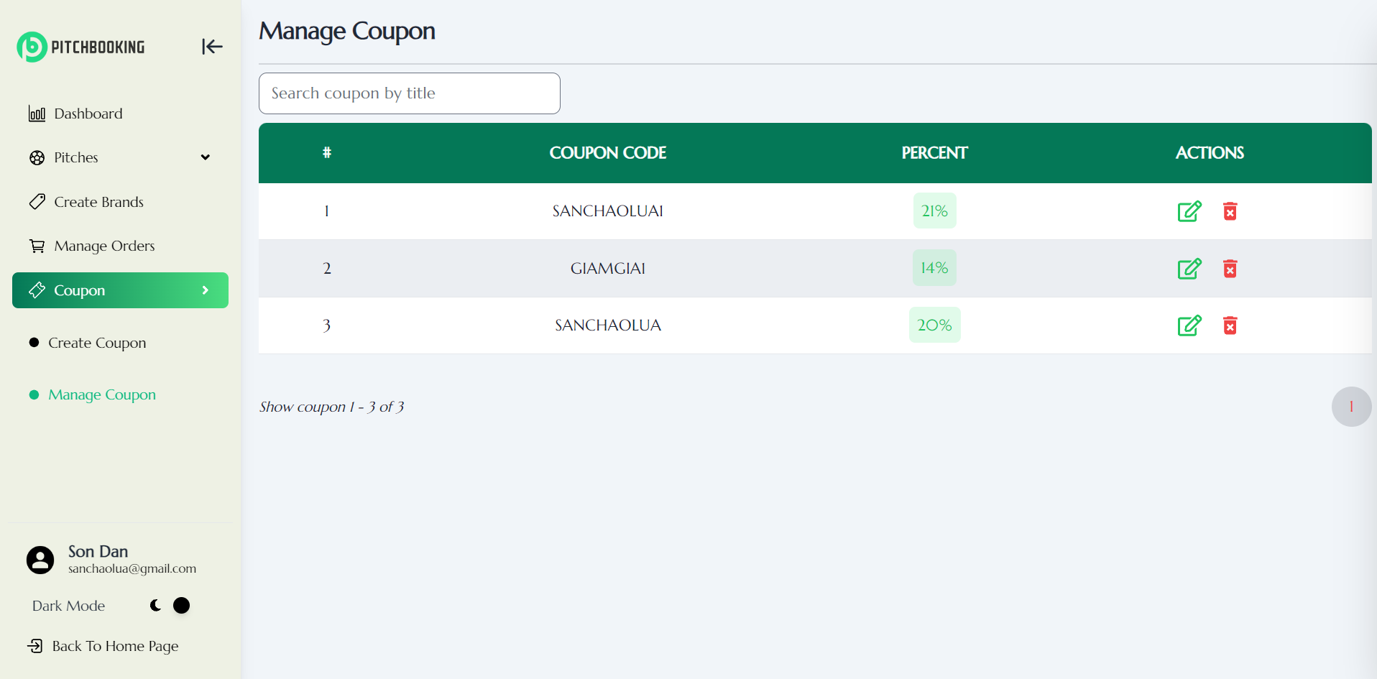

4

2

3

1

Figure 70: Pitch Owner Manage Coupon Page

* Number 1: Input field for searching coupon by code
* Number 2: Button to update coupon information
* Number 3: Button to delete coupon
* Number 4: Pagination

### 4.3.8 My Order

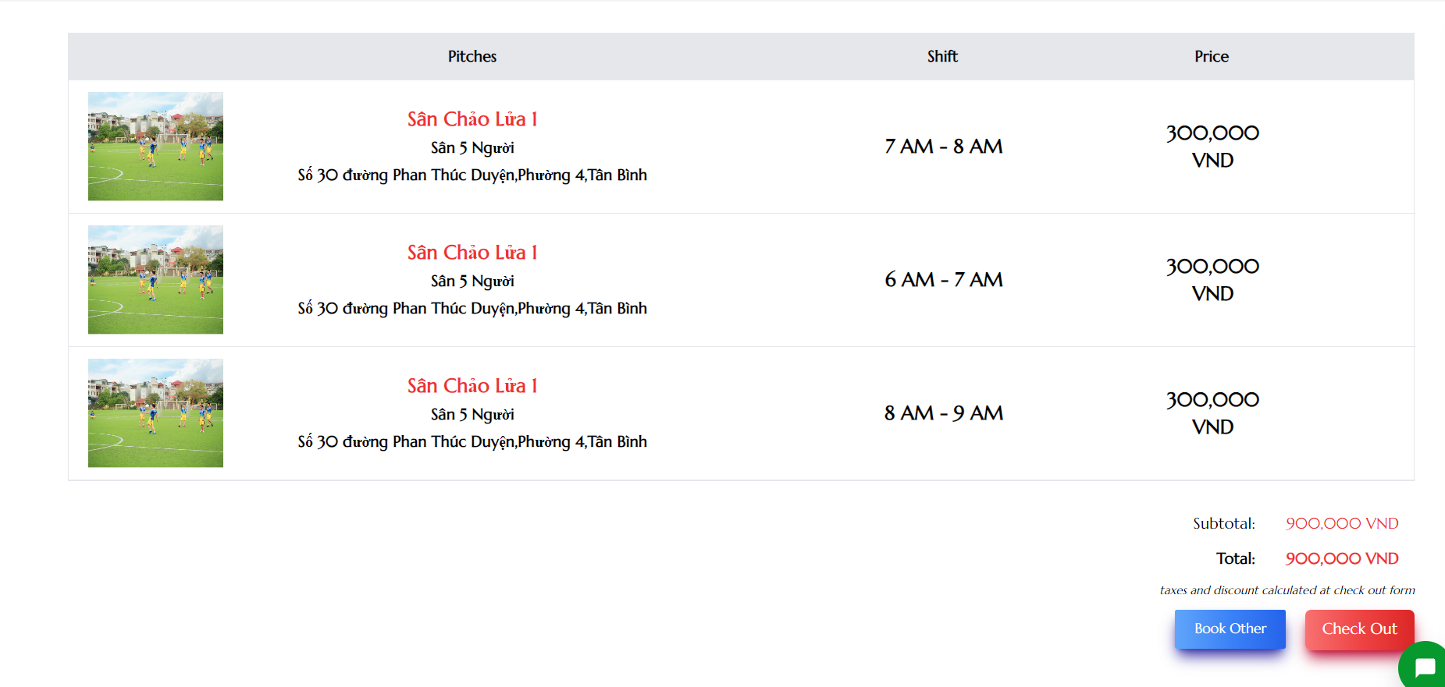

2

1

Figure 71: User Order Page

* Number 1: Button to navigate to home page to continue booking
* Number 2: Button to navigate to checkout page

### 4.3.9 Check Out

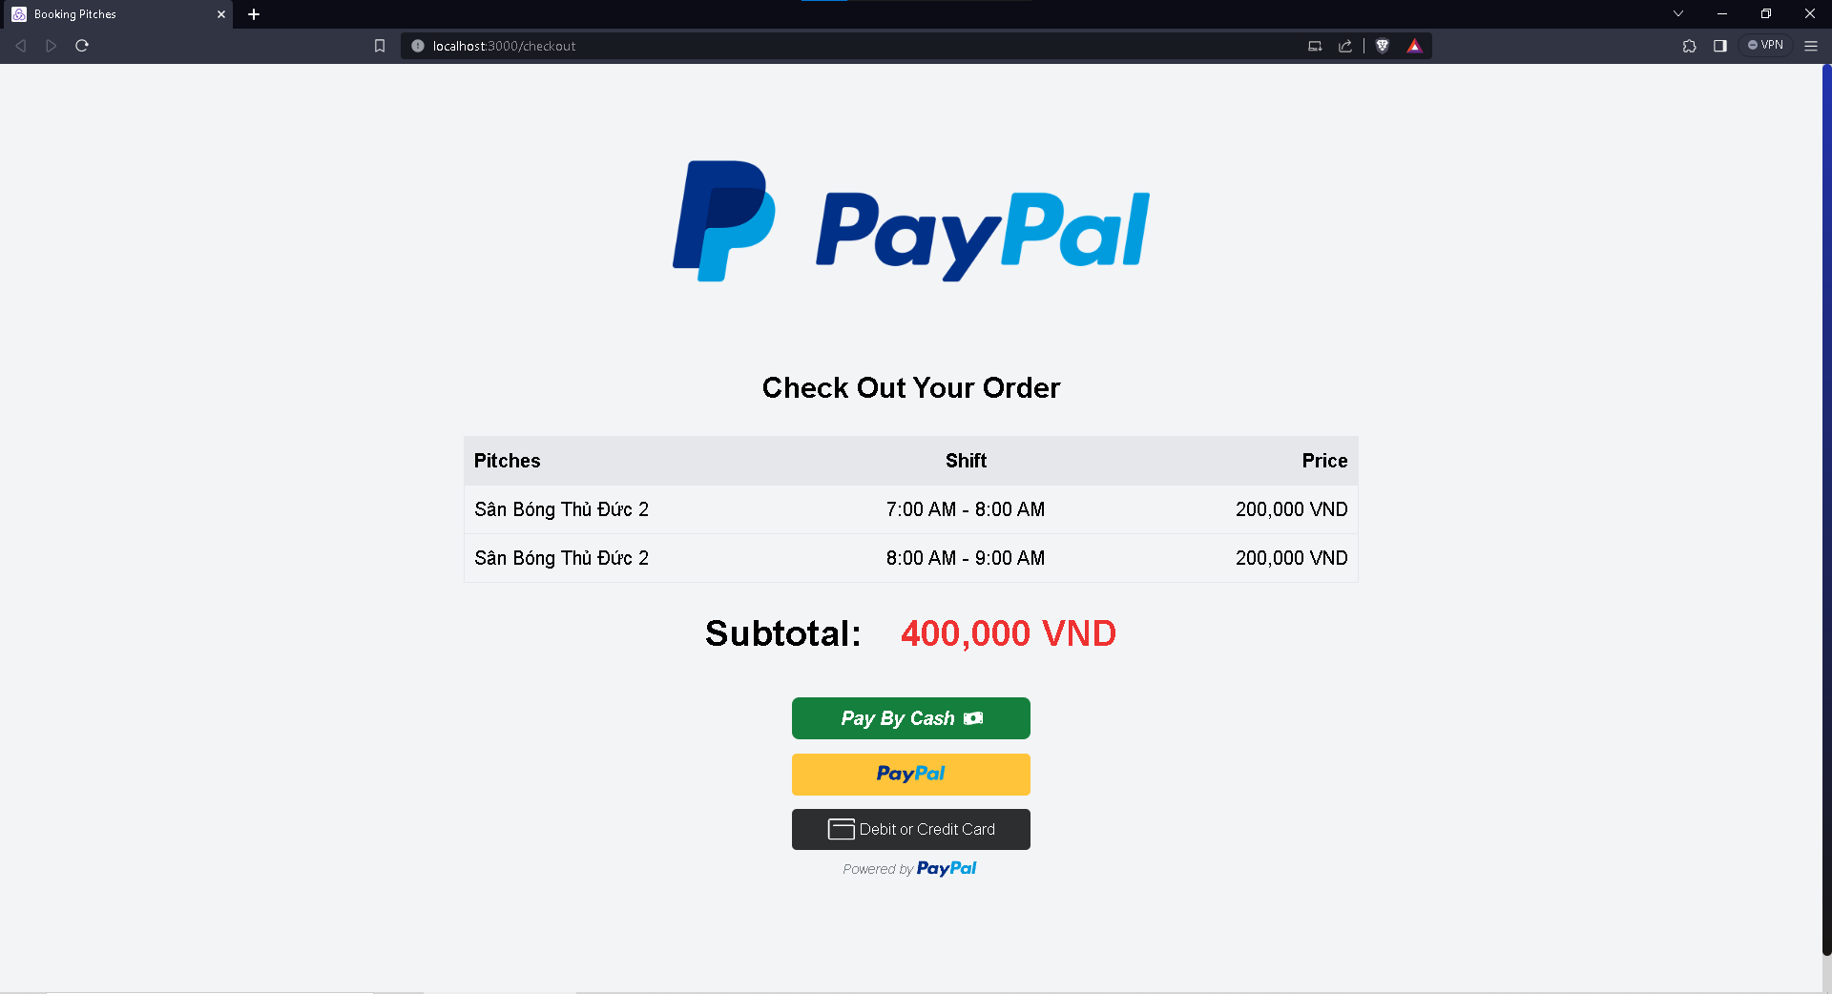

3

1

2

Figure 72: User Check Out Page

* Number 1: Button to pay by cash
* Number 2: Button to pay through PayPal
* Number 3 Button to pay with Debit or Credit Card

### 4.3.10 News Page

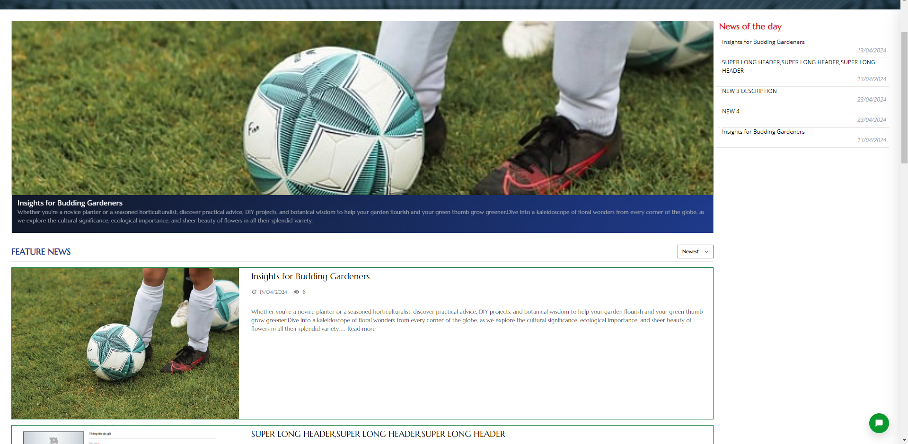

5

4

3

2

1

Figure 73: List Of News

* Number 1: News Thumbnail slider
* Number 2: List news of the day
* Number 3 Sort news
* Number 4: News post
* Number 5: Navigate to news post detail

# CHAPTER 5: IMPLEMENTATION AND TESTING

## 5.1. TTOOLS IN PROJECT

These are technologies and tools that we used to build the project:

* Web app front-end: ReactJS, HTML, tailwindCSS.
* Back-end: NodeJS, ExpressJS.
* DBMS: MongoDB.
* IDE: Visual Studio.
* Version control system: GitHub.
* Browser: Google Chrome, Microsoft Edge.
* Operating System: Windows 10.

## 5.2. TEST PLAN

### 5.2.1. Test Plan

In this project, we use white box testing method to test main functions of the application. The biggest advantage of white box testing is that the testing can begin at an earlier stage and it provide a thorough and detailed assessment of the software's internal workings. The function will be tested are:

* Sign In
* Sign Up
* Sign Out
* Recover password
* Filter pitches
* Search pitches
* View detail’s pitches
* Booking pitches
* View Booking history
* Rating
* View personal information
* Update personal information
* View booking order
* Add pitches
* Delete pitches
* Update pitches
* Delete user
* Update user’s information
* Add category
* Delete category
* Update category

### 5.2.2. Test Result

|  |  |  |  |  |  |
| --- | --- | --- | --- | --- | --- |
| **ID** | **Description** | **Step** | **Expected Result** | **Actual Result** | **Status** |
| TC_01 | Test the Sign In function | -Select “Sign in or Create Account” button in homepage  -Sign In with registered account | Sign in success and move to homepage | As expected | Pass |
| TC_02 | Test the Sign Up function | -Select “Sign in or Create Account” button in homepage  - Select Sign Up  - Input required field with validated information  - Click Sign Up and enter the code has been seen to your email | Sign Up success and move to login page | As expected | Pass |
| TC_03 | Test the Sign Out function | -Select “Sign Out” icon in the homepage | Sign out success | As expected | Pass |
| TC_04 | Test the Recover password function | - Select “Sign in or Create Account” button in homepage  -Select forgot password and enter your email  - Enter the link has been sent to your email and reset the password | Recover password success and move to login page | As expected | Pass |
| TC_05 | Test the Filter pitches function | -Select “PITCHES” on the navigation.  - Choose filter by price, address. | Show pitches filter by price and address. | As expected | Pass |
| TC_06 | Test the Search pitches function | -Select “PITCHES” on the navigation.  -Enter pitch’s name at search bar | Show pitches which name contain character in search bar will be listed out | As expected | Pass |
| TC_07 | Test the View detail’s pitches function | -Select to one pitch in the page | Move to pitch’s detailed of that selected pitch.  The page contains: pitch’s image, pitch’s name, description, price and location | As expected | Pass |
| TC_08 | Test the Booking pitches function | -Select to one pitch in the page  - Choose date and shift then select “Booking” button | The pitch was book will go to the order page | As expected | Pass |
| TC_09 | Test the View Booking history | - Select “Profile” in the header  - Select Booking history | The pitches, time, money which was booked will be showed | As expected | Pass |
| TC_10 | Test the Rating function | - Select to one pitch in the page  - Choose “Rating now!” “Button”  - Input comment and star | -System show the comment and star user has just input | As expected | Pass |
| TC_11 | Test the View personal information function | - Select “Profile” in the header  - Select “Personal”  - Select Personal in new tab | -System show the user’s information | As expected | Pass |
| TC_12 | Test the Update personal information | - Select “Profile” in the header  - Select “Personal”  - Select Personal in new tab  - Input the information and select Update information | System shows update success | As expected | Pass |
| TC_13 | Test the View booking order function | - Select “Profile” in the header  - Select “Admin Workspace,PitchOwner”  - Select Manage Order in new tab | System shows order of the user | As expected | Pass |
| TC_14 | Test the Add pitches function | - Select “Profile” in the header  - Select “Admin Workspace,PitchOwner”  - Select Pitches, Create Pitch in new tab  - Input the information of the pitch  - Select “Add new pitch” button | Add success the new pitch to system | As expected | Pass |
| TC_15 | Test the Delete pitches function | - Select “Profile” in the header  - Select “Admin Workspace,PitchOwner”  - Select Pitches, Manage Pitch in new tab  - Choose delete icon | Delete success the new pitch to system | As expected | Pass |
| TC_16 | Test the Edit pitches function | - Select “Profile” in the header  - Select “Admin Workspace,PitchOwner”  - Select Pitches, Manage Pitch in new tab  - Choose edit icon  - Input the information of the pitch to change  - Select “Update pitches” button | Update success the pitch. | As expected | Pass |
| TC_17 | Test the Delete user function | - Select “Profile” in the header  - Select “Admin Workspace,PitchOwner”  - Select Manage User in new tab  - Choose delete icon | Delete success the user. | As expected | Pass |
| TC_18 | Test the Update user’s information function | - Select “Profile” in the header  - Select “Admin Workspace,PitchOwner”  - Select Manage User in new tab  - Choose edit icon  - Input the information of the user to change  -Select “Update user” icon | Update success the user. | As expected | Pass |
| TC_19 | Test the Add category function | - Select “Profile” in the header  - Select “Admin Workspace,PitchOwner”  - Select Category, Create Category in new tab  - Input the information of the category  - Select “Create new category button” | Add success the new category to system | As expected | Pass |
| TC_20 | Test the Delete category function | - Select “Profile” in the header  - Select “Admin Workspace,PitchOwner”  - Select Category, Manage Category in new tab  - Choose delete icon | Delete success the category. . | As expected | Pass |
| TC_21 | Test the Update category function | - Select “Profile” in the header  - Select “Admin Workspace, PitchOwner”  - Select Category, Manage Category in new tab  - Input the information of the category to change  -Select “Update category” icon | Update success the category. | As expected | Pass |

Table 28: Test result

# CHAPTER 6: CONCLUSIONS

## 6.1. RESULT

* Through this project, understand how to operate and build a website through the use of React JS Framework in terms of front-end.
* In terms of back-end, understand how the website's API system works and deploys it through the use of Express JS, which is a framework of Node JS.
* Ensure that the main functions of a booking filed website are always operational, so that they can be delivered to users.
* In addition, we have developed additional features: new Map (because Google Map has been blocked in Vietnam), notification function, improved multi-user interface (responsive), fixed logic problems in set price (price) and add discount code function, Zalo Payment.

## 6.2. LIMITATIONS

* Haven't researched in-depth about application safety and security issues.
* The product suggestion system through AI has not been integrated, a quite important function of an e-commerce website.

## 6.3. FUTURE WORK

* Apply AI for recommend pitch
* Improve website performance
* Improve safety and security issues
* You can find the solution by following this link: <https://github.com/SonDanh2501/CAPSTONEPROJECT>

# REFERENCES

1. Nguyễn, H. (2019, December 15). Tìm hiểu về tailwind CSS. Viblo. https://viblo.asia/p/tim-hieu-ve-tailwind-css-924lJp6WKPM
2. ReactJS la gi? Những điều ban chưa biết về ReactJS. (2022, November 13). FPT Aptech.

<https://aptech.fpt.edu.vn/reactjs-la-gi.html>

1. Wikimedia (2021, June 13). Introduction to Node.js.

<https://en.wikipedia.org/wiki/Node.js>

1. Alexander S. Gillis (2023, March). What is MongoDB?

<https://www.techtarget.com/searchdatamanagement/definition/MongoDB>

1. Everything You Should Know About Express JS (2022, May).

<https://kinsta.com/knowledgebase/what-is-express-js/>